William James Allen Vidal
September 18, 1984 – November 11, 2004

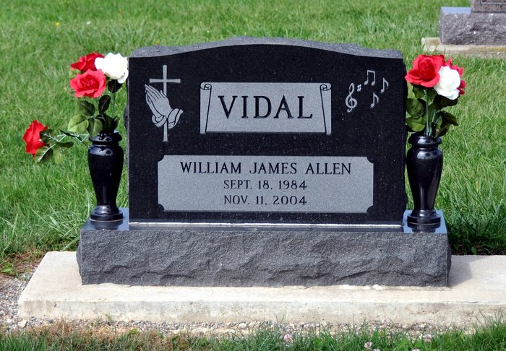

William "Will" James Allen Vidal, 20, of rural Decatur, died on Thursday, November 11, 2004 in Allen County in a traffic accident.
He was born on September 18, 1984 in Allen County to Richard B. and Christine Elzey Vidal. His father is deceased, but his mother, now Christine Ashbaugh, lives in Troy, Ohio. He was a 2003 graduate of Adams Central High School, where he was active in Future Farmers of America, the National Chorus for FFA, wrestling, football, and baseball. He was a mechanic for Butler Telecom in Fort Wayne and a member of St. Luke's United Church of Christ, rural Decatur.
Other survivors are his grandparents, Max and Dianne Elzey of Decatur; his great-grandmother, Mary Ann Holthouse of Decatur; one brother, Jeremy Vidal of Fort Wayne; one sister, Monica Eloph of Troy, Ohio; five uncles: Dan Elzey (wife, Gale) of rural Decatur; Jesse Vidal (wife, Pat) of Pennville, Indiana; Billy Vidal of Florida; James Vidal of Bluffton; and Roger Davis of Tennessee, and four aunts: Mrs. Randy (Laurie) Gay of Decatur; Mrs. Allen (Paula) Brannon of Georgia, and Mrs. Ken (Cindy) Roger and Patricia K. Vidal, both of Florida.
Funeral services will be held at 11 a.m. Monday in Haggard and Sefton Funeral Home, Decatur, with Pastor Tim Timmons and Rev. Rick Pulling officiating. Burial will be in St. Luke's United Church of Christ Cemetery. Visiting hours will be from 11 a.m.-7 p.m. Sunday in Haggard and Sefton Funeral Home.
Memorials are to the Adams County Community Foundation's Angel Cancer Fund or to the Heart Club of Adams County.
Decatur Daily Democrat, Adams County, IN; November 13, 2004

