Harold James Shoaf
October 8, 1910 – November 8, 1984

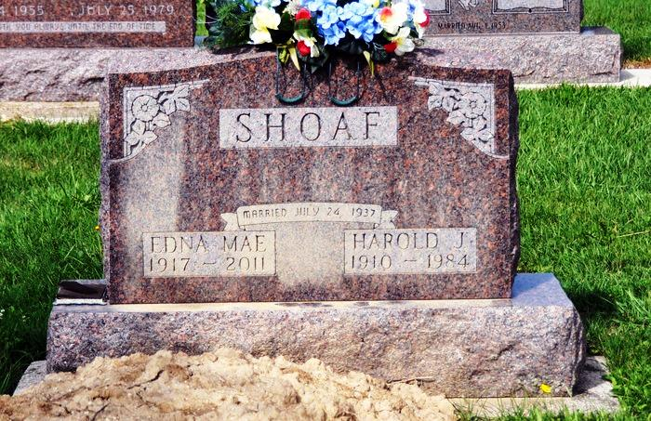
Harold J. Shoaf, 74, Hernando, Fla., self-employed plumber in the Decatur area for 20 years and also a former employee of Central Soya and the General Electric Co. in Decatur, died unexpectedly at 1:15 p.m. Thursday in Citrus County Memorial Hospital, Inverness, Fla.
He was stricken at home a short time earlier with an apparent heart attack.
He was a resident of Route 6 Decatur, until moving to Florida in 1976. He was a lifelong member of Zion United Church of Christ and graduated from Decatur High School. Born in Kirkland Township on October 8, 1910, he was a son of Chester and Blanche Hoffman- Shoaf, and was married July 24, 1937, to Edna M. Lautzenheiser; she survives.
Also surviving are five children, Mrs. Edward (Judy) Mosshammer, Hamilton, Ind.; Mrs. John (Kathy) Frey, Fairborn, O.; Miss Jane Shoaf, Salt Lake City, Utah; Gary Shoaf, Monroeville; Lee Shoaf, Route 2 Decatur; a sister, Mrs. Robert (LaVere) Light, Route 6, Decatur; a brother, Arthur Shoaf, Route 1, Berne; and 10 grandchildren.
Services will be held Sunday at 1:30 p.m. at Zwick, Boltz & Jahn Funeral Home, Rev. Lawrence Balleine officiating. Burial will be in St. Luke's Cemetery, Honduras. Friends may call at the funeral home after 2 p.m. Saturday. Memorials are to the church.
Decatur Daily Democrat, Adams County, IN; November 9, 1984

