Chester W. Shoaf
May 15, 1887 – November 11, 1965

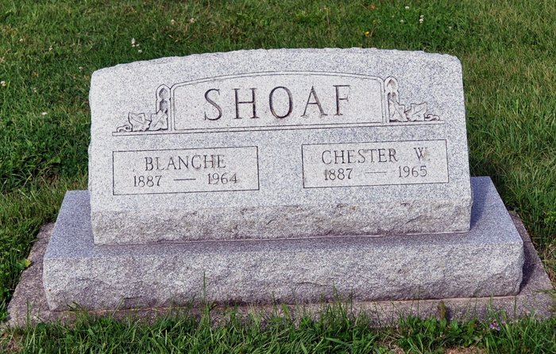
Chester W. Shoaf Dies Last Evening
Chester W. Shoaf, 78, of Monroe Route 1, well known farmer and former employee of the Adams County Highway Department, died at 6:20 p.m. Thursday at St. Joseph's Hospital, Fort Wayne, where he had been a patient since Tuesday afternoon. He had been ill for the past 10 months.
He was born near Oak Harbor, O., May 15, 1887, a son of William and Sadie Benedict-Shoaf, and had lived in Adams County most of his life. He was married to Blanche Hoffman August 1, 1908. His wife preceded him in death October 30, 1964.
Surviving are three sons, Arthur Shoaf of Monroe, Harold Shoaf of Decatur Route 6, and Raymond R. Shoaf of Decatur Route 4; one daughter, Mrs. Robert (LaVere) Light of Decatur Route 6; 24 grandchildren; 28 great-grandchildren; three brothers, Fred Shoaf of Waynedale, Ed Shoaf of Decatur Route 4, and Charles Shoaf of Decatur Route 6, and four sisters, Mrs. Noah (Lulu) Egly of Monroe Route 1, Mrs. Mable Lininger of Decatur Route 4, Mrs. Mae Musser of Decatur Route 3, and Mrs. Ora (Ireta) Ratcliff of Decatur Route 6. One brother is deceased.
Funeral rites will be conducted at 2 p.m. Sunday at the Zwick Funeral Home, with Rev. William C. Feller officiating. Burial will be in the St. Luke Cemetery, Decatur Route 4. Friends may call at the funeral home after 7 p.m. today until time of the services.
Decatur Daily Democrat, Adams County, IN; November 12, 1965

