Brooks Marcel Scherry
July 4, 1914 – October 16, 1914

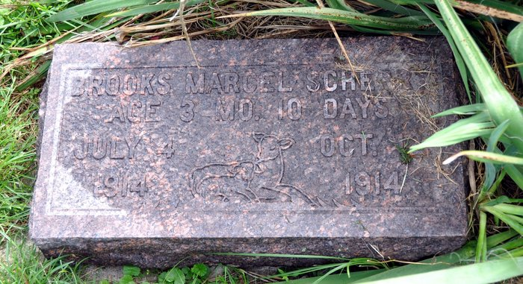
YOUNG BABE DEAD
Brooks, the three months' old son of Mr. and Mrs. William Scherry, residing in Kirkland Township, passed away early this morning, after having suffered for several weeks with whooping cough.
The babe is survived by the parents and a little sister.
The funeral services will be held Sunday morning at the Honduras German Reformed Church and interment will be made in the church cemetery.
Decatur Daily Democrat, Adams County, IN; October 16, 1914

