Glenn L. Roth
May 14, 1915 – November 11, 1989

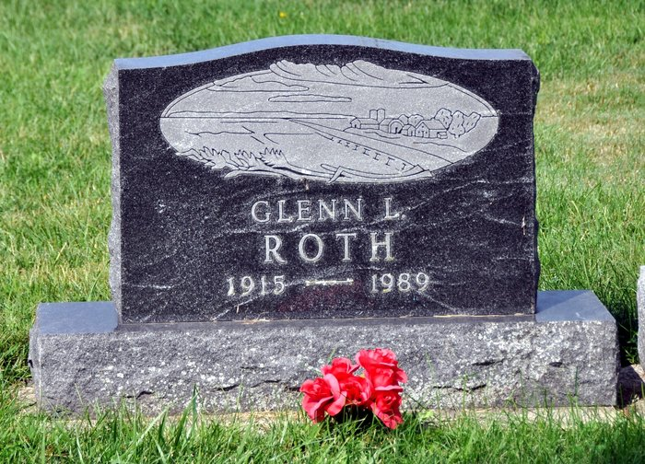
Glenn L. Roth, 74, Route 4, Decatur, died at 5:30 a.m. Saturday at home. He was born on May 14, 1915 in Adams County to Christian and Anna Ebnit Roth and was a retired farmer and a member of St. Luke's United Church of Christ.
Surviving are several nieces and nephews. Four sisters and four brothers are deceased.
Funeral services are at 10 a.m. Wednesday in Haggard and Armes Funeral Home, Rev. Peter Smith officiating. Burial will be in St. Luke's Cemetery. Visiting hours are 2-5 and 7-9 p.m. Tuesday. Preferred memorials are to the church.
Decatur Daily Democrat, Adams County, IN; November 13, 1989

