Frances Roth
July 2, 1907 – July 23, 1936

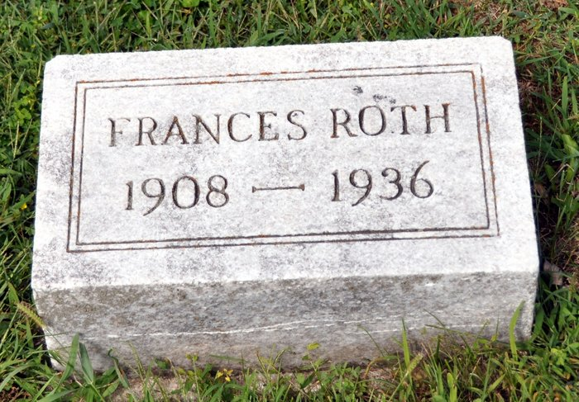
DEATH CLAIMS FRANCES ROTH
Kirkland Township Lady Dies Thursday after Short Illness
Miss Frances Roth, 29, daughter of Christ and Ann Abnet-Roth of Kirkland Township, a half mile north of Honduras, died at her home Thursday afternoon at 2 o'clock of complications. Death followed a one day's illness.
Miss Roth spent practically her entire life in Adams County. She was born in Newcastle. She was a graduate of the Kirkland High School, and was a member of the St. Luke's Reformed Church in Kirkland Township.
Surviving besides the parents are the following brothers and sister: John Roth, Kirkland Township, Fred Roth, Fort Wayne, Albert Roth, Kirkland Township; David Roth, rural route, Decatur; Mrs. Harve Mankey, Kirkland Township, and Glen Roth at home. Two sisters and a brother are deceased.
Funeral services will be held Sunday afternoon at 2 o'clock at the St. Luke's Reformed Church with the Rev. H. H. Meckstroth, officiating. Burial will be made in the church cemetery.
Decatur Daily Democrat, Adams County, IN; July 24, 1936

