Rosa (Meyer) Presdorf
May 6, 1862 – March 28, 1936

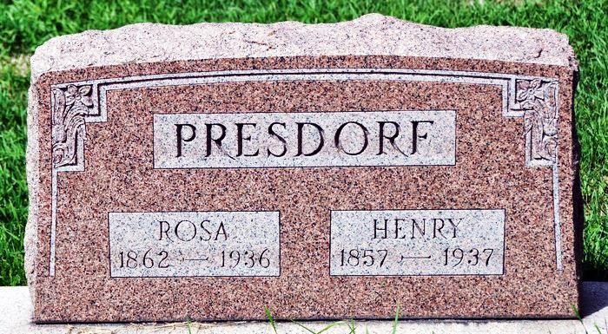
ROSE PRESDORF DIES SATURDAY
Adams County Native Dies Saturday At Home in LaGrange
Mrs. Rose Presdorf, 73, LaGrange, died Saturday at 5 a. m. Death was due to complications. The deceased was born May 6, 1862, in French Township, Adams County, a daughter of Mr. and Mrs. Abraham Meyer. She was a member of the St. Luke’s Reformed Church.
Surviving besides the husband, Henry Presdorf, are two sons, Noah and Willis, north of LaGrange and a daughter, Mrs. Otto Klopfenstein of Burr Oak, Michigan. Mrs. Presdorf was a sister of the late Eli and John Meyer of this city and also an aunt of Mrs. Huber DeVoss and Mrs. Chalmer Hower.
Funeral services will be held Tuesday at 2 p.m. at the St. Luke's Reformed church, Adams County, and burial will be made in the church cemetery. Rev. Meckstroth will have charge of the services.
Decatur Daily Democrat, Adams County, IN; March 30, 1936

