Loren W. Myers
July 20, 1928 – March 26, 2012

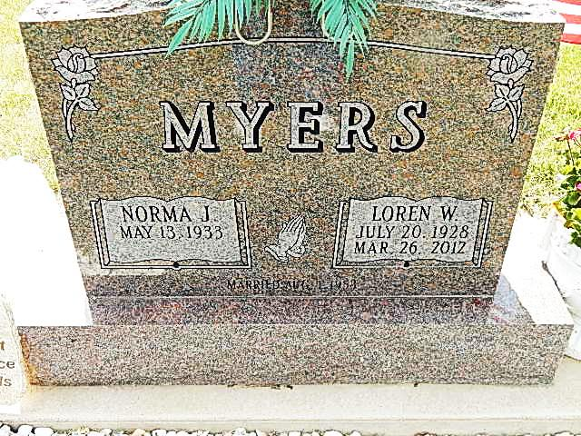

Photos by Alicia Kneuss

Loren W. Myers 83, of Monroe, passed away Monday March 26th at Woodcrest Nursing Center in Decatur. He was born on July 20, 1928 to the late Frank and Minnie (Foreman) Myers in Adams County, Indiana. On August 1, 1953 Loren married Norma J. (Funk). Loren was a lifelong farmer and was also a plasterer for many years. He was a lifelong resident of Adams County. He attended The Bridge Community Church in Decatur and First Christian Church in Haines City, FL. and served for many years on the Adams County Plan Commission.
Loren is survived by his wife Norma J. Myers of Monroe, IN., two daughters, Sherrill A. (Wayne) Frock of Monroe, IN., Diana S. (Steve) Bailey of Decatur, IN., two brothers Donald (Mary) Myers of Constantine, MI., Larry (Darlene) Myers of Decatur, IN., one sister Dorothy Brown of Fort Wayne, IN., seven grandchildren Missy (Paul) Walker, Bob (Angela) Frock, Casey (JD) Nidlinger, Jon (Robin) Frock, Tim (Michelle) Frock, Alex (Tyler) Roach, Madison Bailey, and six great grandchildren Jarrett Bailey, Jamison Roach, Elaine Nidlinger, Haylie Frock, Kylee Frock, Daymon Frock, and two step great grandchildren Bryan and Hannah Walker. He was preceded in death by his parents, his son Ronald W. Myers, two sisters Faye Miller, and Marcile Williamson.
Visitation will be held on Sunday, April 1, 2012 from Noon to 4pm at Haggard Sefton & Hirschy Funeral Home and one hour prior to services on Monday. Funeral will be held on Monday April 2, 2012 at 10:30 a.m. at Haggard Sefton & Hirschy. Burial will be at St. Luke’s Cemetery. Pastor Jim Compton will be officiating. Memorials may be made to Family Life Care.

Haggard-Sefton & Hirschy Funeral Home online obit (accessed March 27, 2012)

