Dale Edward Mankey
August 31, 1920 – February 7, 2004

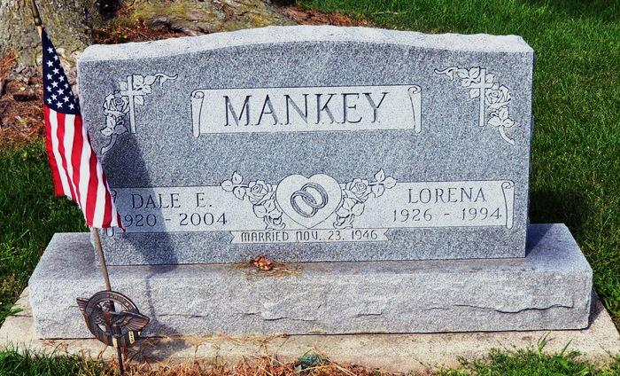
Dale E. Mankey, 83, of Satsuma, Florida, a former Decatur resident, died Saturday. He was a member of St. Luke United Church of Christ in rural Decatur.
Surviving are his second wife, Edith; a son, Dale E. Mankey Jr. of Decatur; four daughters, including Jan Roop of Monroeville; 15 grandchildren; and five great- grandsons.
His first wife, Lorena, is deceased.
A memorial service will be held at 4 p.m. this Sunday in the Fellowship Hall at St. Luke United Church of Christ, with a dinner to follow.

Decatur Daily Democrat, Adams County, IN; Tuesday, February 10, 2004
Contributed by Karin King

*****
Dale E. Mankey Sr., 83, died February 7, 2004 at his home in Satsuma. A Navy veteran, he served on the Pacific Front during WW II. He retired from a lifetime of farming in Indiana and factory work where he worked for Franklin Electric, giving more than 30 years of service. He and Lorena moved to Satsuma upon retirement. He was a member of St. Luck UCC in rural Decatur, Ind., and attended the San Mateo Church of the Nazarene upon retiring to Florida.
He was preceded in death by his wife of 46 years, Lorena Mankey.
Surviving are his wife, Edith Mankey; son, Dale E. Mankey Jr., Decatur, Ind.; daughters, Eva Jane Mankey, Satsuma; Jan Roop, Monroeville, Ind.; Sharon Egly, New Haven, Ind.; and Dianne Eldridge, Ore.; 15 grandchildren and five great-grandsons.
A memorial service was held Feb. 9 at San Mateo Church of the Nazarene.
Watts Funeral Home in San Mateo is handling arrangements.

Palatka Daily News, Palatka, FL; February 10, 2004

