Lafie L. Leeth
July 28, 1929 – May 31, 1997

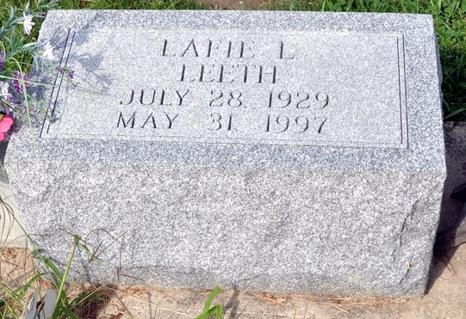
Lafie L. Leeth, 67
Retired 43-year employee of Franklin Electric Co., Lafie L. Leeth, 67, died at 11:37 p.m. Saturday at Ossian Health Care. Mr. Leeth retired in 1994 from Franklin Electric. He also was a self- employed, licensed journeyman electrician.
He was born in New Haven on July 28, 1929 to Lafayette E. and Olive Price Leeth. His marriage in Adams County on April 29, 1950 was to Gladys Mankey, who died Dec. 19, 1989.
Mr. Leeth was a member of the St. Luke's United Church of Christ.
Surviving are two sons, Michael Leeth of Markle and Terry Leeth of Bluffton; six sisters, Mrs. Stephen (Cynthia) Kosinksi of East Hampton, Conn., Mrs. Norman (Karen) Bailey of Geneva, Mrs. Allen (Elaine) Newcomb of Colorado Springs, Colo., Mrs. Loren (Julie) Jackson of Fort Wayne and Mrs. David (Jennifer) Meadows and Vickie Leeth, both of Bluffton. A sister, Mrs. Donald (Olive) Lee of Paulding, Ohio; 15 grandchildren and one great-grandchild also survive.
Services will be at 10:30 a.m. Thursday at St. Luke's United Church of Christ in Adams County with Rev. Jerry Flueckiger officiating. Burial will be in St. Luke's Cemetery.
Calling hours at Goodwin Memorial Chapel will be from 6 to 9 p.m. Tuesday and from 12 noon to 9 p.m. Wednesday; calling for one hour also at the church prior to services. Memorials to the church or to the Wells County Chapter of the American Cancer Society.
Bluffton News-Banner, Wells County, IN; June 2, 1997

