Cora Elvina Klickman
April 11, 1897 – February 11, 1967

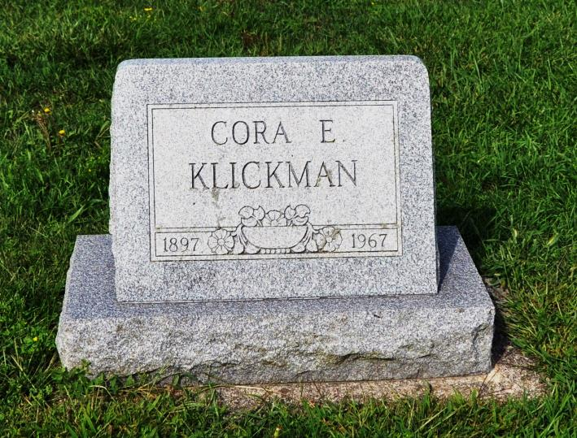
Cora E. Klickman is Taken by Death
Miss Cora Elvina Klickman, 69, a lifelong resident of Adams County, died at 10:30 a.m. Saturday at her home in Bluffton, Route 4. She had been in failing health for two weeks and critically ill three weeks.
Born in French Township April 11, 1897, she was a daughter of Ferdinand and Augusta Yake-Klickman, and had never married.
Miss Klickman was a member of St. Luke's United Church of Christ.
Surviving are two brothers, August and Otto Klickman, and two sisters, Miss Anna and Miss Hulda Klickman, all of Bluffton, Route 4. A sister, Bertha, and a brother, William A., are deceased.
Funeral services will be conducted at 10 a.m. Tuesday at the Winteregg-Linn Funeral Home, with Rev. H.E. Settlage officiating. Burial will be in St. Luke's Cemetery. Friends may call at the funeral home until time of the services.
Decatur Daily Democrat, Adams County, IN; February 13, 1967

