Otto William Hoffman
February 4, 1895 – September 10, 1977

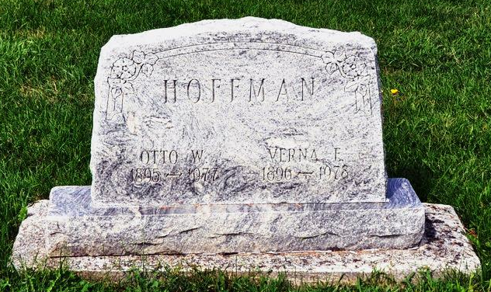
Otto William Hoffman, 82, of 304 Van Buren St., Monroe, a former Adams County Commissioner, died at 6:40 a.m. today at the Adams County Memorial Hospital. He had been in failing health for one year. Mr. Hoffman, a Democrat, served as county commissioner from 1950-1954 and was a former school teacher and farmer.
He was a member of the St. Luke's United Church of Christ at Honduras, where he was on the consistory as an elder and trustee, and was active in church affairs. Mr. Hoffman, an avid sports fan, was a member of the Moose Lodge 1311.
Born in Adams County on Feb. 4, 1895, he was the son of Jonas and Lucy Zaugg-Hoffman, and was united in marriage on March 17, 1917 in Decatur, to Verna Owens, who survives.
Also surviving are seven children, Dale Hoffman, Edwardsburg, Mich.; Kenneth Hoffman, Monroe; Mrs. Art (Dorothy) Beeler, Decatur; Mrs. Bernard (Virginia) Gase, Fort Wayne; Mrs. Doyle (Phyllis) Winteregg, Berne; Charles Hoffman, Monroe; Thomas Hoffman, Decatur; one sister, Mrs. Mary Fisher, Route 4, Decatur; one brother, Barry Hugo Hoffman, Camden, Mich.; 22 grandchildren and 16 great- grandchildren. One brother and two sisters preceded him in death.
Funeral services will be held Monday at 10:30 a.m. at the Zwick Funeral Home, with Rev. Kent Ulery officiating. Burial will be in the St. Luke's United Church of Christ Cemetery. Friends may call at the funeral home after 10 a.m. Sunday. Preferred memorials are to the Cancer Society or St. Luke's Church.
Decatur Daily Democrat, Adams County, IN; September 10, 1977

