Leonard D. Funk
July 5, 1928 – December 10, 1995

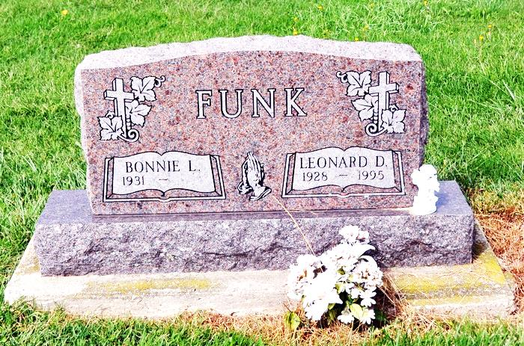

Leonard D. Funk, 67

Decatur resident Leonard D. Funk, 67, died Sunday at Adams County Memorial Hospital in Decatur. Born July 5 1928 in Adams County, he was the son of Clark and Emma Dick Funk. He married Bonnie L. Baumgartner, who still survives, on Nov. 12, 1949.
He was a former employee of Yost Construction in Decatur and Habig Trucking of Bluffton. He was also a member of St. Luke’s United Church of Christ.
Surviving, in addition to his wife, are three daughters, Mrs. Robert (Judy) Newman of Lenior, N.C., Mrs. Paul (Janis) Whitcomb and Mrs. Don (Joy) Erxleben, both of Decatur; three brothers, Kenneth Funk of Decatur, Jerry Funk of Portland and Larry Funk of Mesa, Ariz.; two sisters, Mrs. Loren (Norma) Myers of Monroe and Mrs. Charles (Eileen) Hoffman of Sun City, Ariz.; and 12 grandchildren.
Friends may call from 2 to 5 p.m. and 7 to 9 p.m. on Wednesday at Haggard & Armes Funeral Home where services will be at 10 a.m. on Thursday. Rev. Jerry Fleuckiger will officiate the ceremony. Burial will be at St. Luke's Cemetery in Decatur. Memorials to the Adams County Home Health Care.
Bluffton News-Banner, Wells County, IN; December 11, 1995

