Emil Louis Egly
April 3, 1861 – October 20, 1915

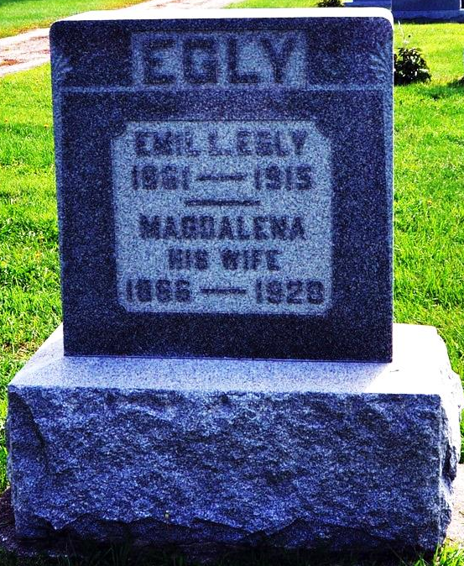

DECATUR, Ind. Oct 21 –

After many weeks of suffering that had its origin in an injury received when he was kicked by a horse, Emil Egley, a well-known farmer residing west of Decatur, in Washington Township, is dead. Mr. Egley was attending a sale at the George Bright farm in Kirkland Township, when he received his injury. He was standing behind the animal when it became frightened and kicked, striking him in the lower part of the abdomen and causing an intestinal rupture.
Mr. Egley was born in Berne, Switzerland, on April 3, 1861, and grew to manhood in his native country, but at the age of 21 years came to the United States to make his home.
He is survived by the widow, Magdalena Egley and a family of sixteen children.

Fort Wayne Sentinel, Fort Wayne, IN; Oct. 21, 1915

Contributed by Karin King

