Edith B. (Smallback) Egly
April 27, 1922 – July 20, 1979

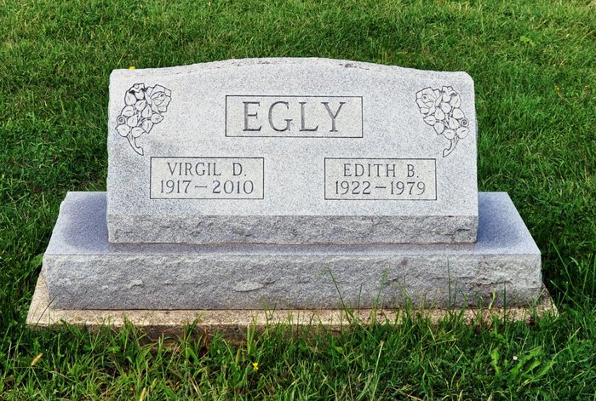

Carl Egly's Mother, 57, Dies Suddenly

Mrs. Virgil (Edith B.) Egly, 57, of Fort Wayne was dead on arrival at 9:20 p.m. Friday at Bluffton Community Hospital at Bluffton, O. Death which came unexpectedly was due to a stroke.
Mrs. Egly and her husband were enroute home after spending three weeks in Florida, when she became suddenly ill as they were passing through Bluffton, O. The couple had lived in Fort Wayne since 1970.
Born April 27, 1922, in Fort Wayne, she was a daughter of Wilford Smallback of Fort Wayne and the late Lavilla Smallback. Her marriage to Mr. Egly, who survives, took place in June 1946.
In addition to the husband and father, she is survived by a daughter, Mrs. Randy (Mary) Sparks of Orlando, Fla.; two brothers, Edward Smallback of Fort Wayne and Robert Smallback of Churubusco, and three grandchildren.
Calling will be after 10 a.m. Sunday at the Thoma-Rich Funeral Home where services at 1:30 p.m. Monday will be in charge of Edward Geans. Burial will be in Honduras Cemetery in Adams County.
Bluffton News-Banner, Wells County, IN; July 21, 1979

