Albert W. Dolch
July 3, 1914 – April 24, 1986

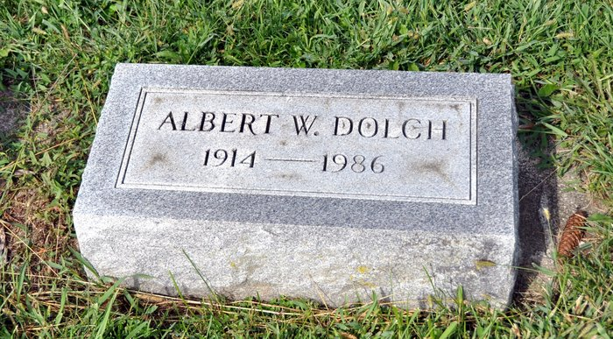

Albert Dolch
Services were held Saturday morning at Thoma-Rich Funeral Home, Bluffton, for Albert Dolch, 71, Cooper Care Center, Bluffton, who died Thursday in Wells Community Hospital, Bluffton. Burial was in St. Luke's Cemetery.
He was a member of St. John's United Church of Christ, Vera Cruz. Born in Wells County on July 3, 1914, he was the son of Henry and Catherine Hoffman-Dolch, and was never married.
Survivors include two brothers, Edward Dolch, Portland, and Martin Dolch, Meadowvale Care Center, Bluffton, and two sisters, Mrs. Ida Kohler and Mrs. Anna Neuenschwander, both of Berne.
Decatur Daily Democrat, Adams County, IN; April 28, 1986
*****
Albert Dolch, 71, Dies After Stroke; Funeral Rites Saturday
Albert Dolch, 71, who had been a resident of the Cooper Community Care Center, died of a stroke at 2:30 p.m. Thursday at Wells Community Hospital, where he had been a patient one day.
A member of St. John's United Church of Christ, Mr. Dolch was born July 3, 1914, in Wells County to Henry and Catherine Hoffman Dolch. He never married.
Surviving are two brothers, Edward Dolch of Portland and Martin Dolch of Meadowvale Care Center, and two sisters, Mrs. Ida Kohler of Berne and Mrs. Anna Neuenschwander of Berne.
Calling after 7 p.m. today will be at the Thoma-Rich Funeral Home. Services there at 10:30 a.m. Saturday will be in charge of Rev. Randy Rossman and burial will be in St. Luke's Cemetery in Adams County.
Bluffton News-Banner, Wells County, IN; April 25, 1986

