Jack Andrews
August 8, 1925 – June 22, 2014

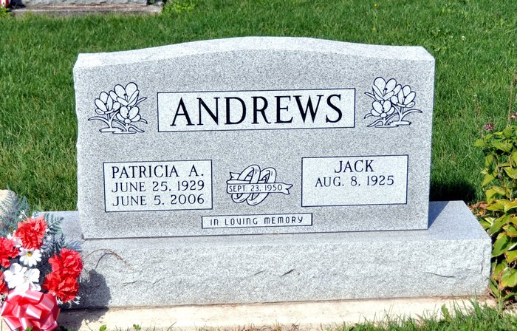

Mr. Jack Andrews, 88 of rural Decatur, IN died at his residence on Sunday, June 22, 2014. Jack was born on August 8, 1925 in Adams County, IN to the late Harrison and Hattie Mae (Hoffman) Andrews.
On September 23, 1950 he married Patricia A. Myers. She preceded him in death on June 5, 2006. Jack was a member of St. Luke Church.
He was a farmer and bus driver for Adams Central Schools. He was a lifetime member of the Moose Lodge #1311 and a member of the Indiana Bus Driver Association.
Survivors include his 6 sons, Donald E. (Linda) Andrews, Ross L. (Vicky) Andrews both of Monroe, IN, Gary R. Andrews, Jerry T. (Rhonda) Andrews, Randy W. (Sandra) Andrews all of Decatur, IN; Scott D. (Jannaya) Andrews of Rockford, OH; a daughter, Laurinda M. (Jeff) Goode of Indianapolis, IN; 13 grandchildren; 3 great grandchildren; 3 step grandchildren. He was preceded in death by; a son, Steven J. Andrews in 1985; a grandson, Isaac.
Per Jack's request – there will be no public services.
Memorials are to St. Luke Church or ACCF Diabetes Angel Fund.
Decatur Daily Democrat, Adams County, IN; June 23, 2014

