William Dayton Zimmerman
1869 – May 8, 1952

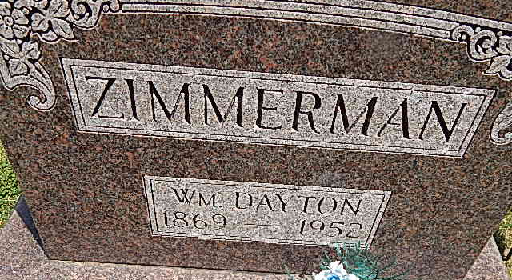 Photo by Alicia Kneuss

William Zimmerman Dies at Richmond
William D. Zimmerman, 83, retired Washington Township farmer, died at 8:45 p.m. Thursday at Reid Hospital in Richmond, following a fall in which he suffered a fractured hip and heart attack.
There are no near surviving relatives. Funeral services will be held at 2 p.m. Sunday at the Zwick Funeral Home, with burial in Pleasant Dale Cemetery. Friends may call at the funeral home after 7 o'clock Saturday evening.

Decatur Daily Democrat, Adams County, IN; May 9, 1952

