Opal (Landis) Zimmerman
July 11, 1887 – September 13, 1965

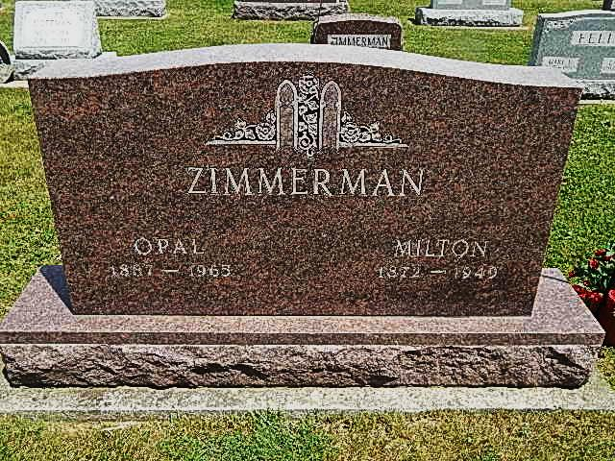
Photo by Alicia Kneuss
Opal Zimmerman Is Taken By Death

Mrs. Opal Zimmerman, 78, of Decatur Route 2, a resident of Adams County practically her entire life, died at 10 o'clock Monday morning at the Adams County Memorial Hospital, following an illness of three weeks. She was born in Darke County, O., July 11, 1887, a daughter of Daniel and Delilah Brooks-Landis, and was married to Charles M. Zimmerman May 2, 1903. Her husband preceded her in death in 1949.
Mrs. Zimmerman was a member of the Pleasant Dale Church of the Brethren.
Surviving are seven daughters, Mrs. Ora (Jennie) McAlhany of Decatur Route 3, Mrs. Ralph (Sue) Wagoner and Mrs. Noah A. (Evelyn) Arnold, both of Fort Wayne, Mrs. W. Edward (Eileen) Rice and Mrs. Paul (Charlotte) Jurt, both of Decatur, Mrs. Victor (Verena) Rice of Lakeville, and Mrs. Walter (Phyllis) Fairchild of Decatur; four sons, Gerald V. Zimmerman of Rome City, Walter R. Zimmerman of Decatur Route 2, Greg L. and Avon H. Zimmerman, both of Decatur; three brothers, George and Ralph Landis, both of Manistee, Mich., and Forest Landis of Muskegon, Mich.; one sister, Mrs. Conrad (Ollie) Olson of Plymouth, Mich.; 43 grandchildren, and 49 great-grandchildren. One daughter, one sister, Mrs. Brandon (Pearl) Lash, four grandchildren and one great-grandchild are deceased.
Funeral services will be conducted at 2 p.m. Thursday at the Pleasant Dale Church of the Brethren, with the Rev. Dolar Ritchey officiating. Burial will be in the Pleasant Dale Cemetery. Friends may call at the Winteregg-Linn Funeral Home after 7 o'clock this evening. The body will be taken to the church at 12 noon Thursday to lie in state until time of the services.
Decatur Daily Democrat, Adams County, IN; September 14, 1965

