Avon H. Zimmerman
February 15, 1924 – March 23, 2005

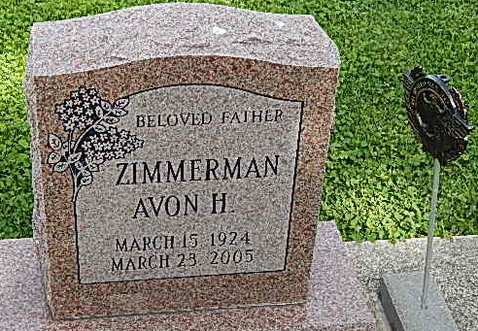
Photo by Alicia Kneuss

Avon H. Zimmerman
Avon H. Zimmerman, 81, of Monroe, died on Wednesday in Lutheran Hospital at Fort Wayne. He was born on March 15, 1924 in Adams County to Charles and Opal Landis Zimmerman. He retired in 1983 from the International Harvester Co., served in World War II as a medic in the U.S. Army, and was a member of American Legion Post 43 in Decatur.
Surviving are five daughters: Kelli Zimmerman of Decatur; Kaylynne Aguilar and Vincetta Lang, both of Lubbock, Texas; Bryanna Martin of Leonard, Texas; and Polly A. Beardsley of Sundown, Texas; one brother, Walter "Bike" Zimmerman of Decatur; three sisters: Sue Waggoner of Fort Wayne; Verena Rice of South Bend; and Phyllis Fairchild of Decatur; 11 grandchildren; and two great-grandchildren. Two daughters, two brothers, five sisters, and two grandsons are deceased.
Funeral services will be held at 4 p.m. Saturday in Haggard and Sefton Funeral Home, with burial in Pleasant Dale Cemetery, rural Decatur, including military graveside rites by the color guard from American Legion Post 43.
Visiting hours will be from 2-4 and 6-8 p.m. Friday in the funeral home. Preferred memorials are to the color guard at Legion Post 43.
The Decatur Daily Democrat, Adams County, IN; March 24, 2005

