Evelyn Corinne (Miller) Yaney
March 3, 1907 – April 18, 2012

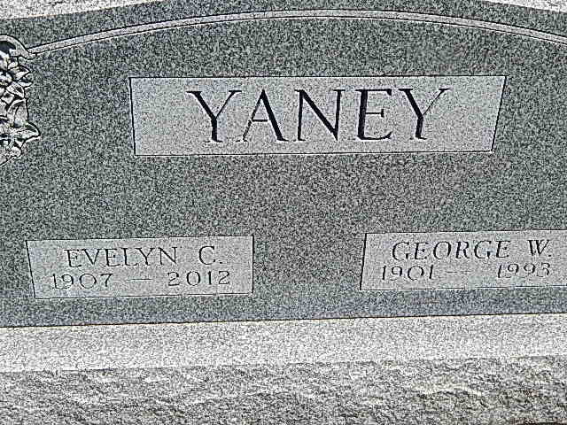
Photo by Alicia Kneuss

Evelyn Corinne Yaney, 105, North Manchester, IN died at 7:40 a.m. Wednesday, April 18, 2012 in Timbercrest Healthcare Center, North Manchester, IN. She was born March 3, 1907 at Charleston, Illinois to Harry Samuel & Cora D. (Railing) Miller. On November 16, 1936 she married George W. Yaney; he died December 19, 1993.
Surviving are two sons, Donald (Joan) Yaney, Chandler, AZ and David (Karen) Yaney, Joliet, IL; four grandchildren and six great-grandchildren. Two brothers and one sister are deceased.
She was secretary and business manager for Col. Fred Reppert and the Reppert School of Auctioneering, Decatur, IN. She was also a secretary for the subsistence Homesteads, a U.S. Government project in Decatur. Later, she and her husband owned and operated the Fort Wayne Ceramic Tile Co. retiring in 1968. She was a member of the Lincolnshire Church of the Brethren, Lincolnshire Women's Fellowship, and the Naomi Study Club at Ft. Wayne, IN. She was a former member of the General Federated Women's Club and the Ft. Wayne Women's Club.
Services will be held Saturday, April 21, 2012 at 10:00 a.m. in Timbercrest Chapel, 2201 East Street, North Manchester, IN. Friends and family may call one hour prior to services at Timbercrest Chapel. Pastor David Bibbee will officiate. Graveside services and burial will be Saturday, April 21, 2012 at 2:00 p.m. at Pleasant Dale Cemetery; Adams County, IN. Arrangements are entrusted to McKee Mortuary, North Manchester, IN.
For those who wish to honor the memory of Evelyn C. Yaney, memorial contributions may be may to Timbercrest Senior Living Community, PO Box 501, North Manchester, IN 46962 or Lincolnshire Church of the Brethren, 6404 S. Calhoun Street, Ft. Wayne, IN 468047 or Visiting Nurse & Hospice Home, 5910 Homestead Rd., Ft. Wayne, IN 46814.

News-Journal, North Manchester, Wabash County, IN; April 19, 2012

