Naomi (Gilbert) Yager
November 20, 1902 – December 29, 1998

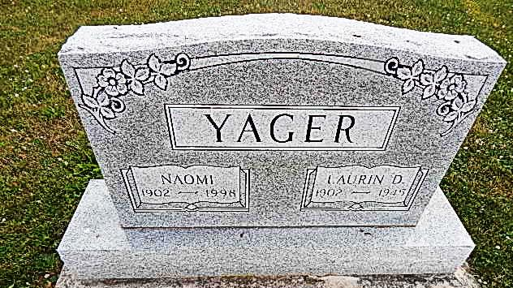
Photo by Alicia Kneuss
Naomi Yager, 96, Berne, who resided for many years in rural Craigville, died at 7:40 p.m. Tuesday in Swiss Village, her residence the past nine years.
She was born on November 20, 1902 in Adams County to William and Emma Wolfe Gilbert and married Laurin D. Yager on July 18, 1930; he died on April 15, 1945.
She was a homemaker and a teacher for 14 years in Adams County at the Stryker School, north of Monroe; the French Township School; and the Yager School, near Berne. She also taught for many years in Wells County, first at the Vera Cruz School and for 23 years at the Lancaster School before retiring in 1969.
She was a 60-year member of Pleasant Dale Church of the Brethren and its Women's Fellowship group.
Surviving is a daughter, Mrs. Gene (Ellen R.) Snyder of Churubusco; two sons, Don Yager of Berne and Wayne Yager of Churubusco; six grandchildren; and two great-grandchildren.
One brother, Chalmer "Jack" Gilbert and two sisters, Leona Gilbert (her twin) and June Tybor, are deceased.
Funeral services will be at 10:30 a.m. Saturday in Pleasant Dale Church of the Brethren, with burial in the church cemetery. Visiting hours are 3-5 and 6-8 p.m. Friday in Zwick and Jahn Funeral Home, Decatur, and 9:30- 10:30 a.m. Saturday in the church.
Preferred memorials are to the church or to Swiss Village.
Decatur Daily Democrat, Adams County, IN; December 31, 1998

