Robert E. Van Ness
July 6, 1911 – April 7, 1977

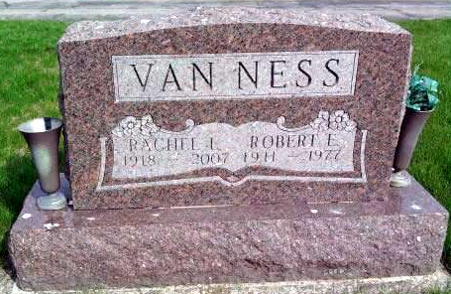
Photo by Deb Curry

Robert E. Van Ness, 65, 9562 Hazelton, Redford, Mich., husband of Rachel Limenstoll-Van Ness, a former resident of Kirkland Township, died unexpectedly Thursday at his home.
He retired from Detroit-Allison Diesel, a subsidiary of General Motors. He was born July 6, 1911, in Patteson, N.J. the son of Charles and Bessie Gill-Van Ness.
He married Rachel Limenstoll on August 10, 1946. His widow has a number of relatives in Adams County.
Survivors, in addition to the widow, include one sister, Mrs. Ronald (Marian) Forsythe, Detroit, Mich.; one brother, Charles Van Ness, St. Petersburg, Fla.
Funeral services will be held Sunday at 4 p.m. at the Harry J. Will Funeral Home, 25450 Plymouth Road, Redford, Mich. Graveside services will be held at 1 p.m. Monday at the Pleasant Dale Cemetery, located west of Decatur. Rev. Edison Reynolds will officiate at the services.
Decatur Daily Democrat, Adams County, IN; April 9, 1977

