Rebecca “Jennie” (Shannon) Stoutenbery
January 14, 1851 – March 4, 1924

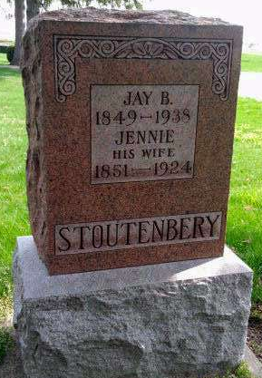
Photo by Deb Curry
Dies of Shock Received in Fall
Mrs. J. B. Stoutenbery, Aged Resident of Kirkland Township, Dies
Mrs. J. B. Stoutenbery, age 73, well known resident of Kirkland Township, died at her home, ten and one-half miles southwest of Decatur at 11 o'clock last night. Death was due to the shock suffered when she slipped and fell January 2.
Mrs. Stoutenbery was a daughter of Mr. and Mrs. Andrew C. Shannon, and was born in Darke County, Ohio, January 14, 1851. She was married to J. B. Stoutenbery in 1876. Mr. and Mrs. Stoutenbery have resided in Adams County since 1883. She was a member of the Christian Church.
Mrs. Stoutenbery is survived by her husband, three daughters, three sisters and ten grandchildren. The daughters are Mrs. A. J. Beavers, of Kirkland Township; Mrs. W. M. Douglas, of Union City, Ind.; and Mrs. Amos K. Stoneburner, of Kirkland Township. The sisters are Mrs. William Duvall, of Anderson; Mrs. Anna Ruffenbarger of Muncie, and Mrs. John H. Berry, of Kirkland Township.
Funeral services will be held from the Pleasant Dale Church at 10 o'clock Friday morning, the Rev. D. M. Byerly and the Rev. Gleason, officiating. Burial will be made at Pleasant Dale.
Decatur Daily Democrat, Adams County, IN; March 5, 1924

