Jay B. Stoutenbery
September 23, 1849 – November 23, 1938

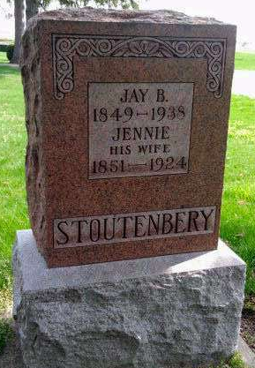
Photo by Deb Curry
Jay Stoutenbery Dies at Hospital
Aged Adams County Man Dies Here; Funeral to Be Friday
Jay B. Stoutenbery, 89, of Adams County, died at the Wells County Hospital at 6:30 this morning, following an illness of four weeks of general infirmities.
The decedent was a son of Mr. and Mrs. Jacob Stoutenbery and was born September 23, 1849. He was married June 27, 1877, at Union City to Miss Rebecca Shannon, who preceded him in death.
Mr. Stoutenbery was a veterinarian and resided on a farm one-half mile south of Honduras. He had been a resident of Adams County 54 years.
Surviving are three daughters, Mrs. A. J. Beavers of Decatur, Mrs. William Douglas, Union City, and Mrs. Amos Stoutenbery, R. R. Decatur, a half-sister, Dr. Elizabeth Conger, of Indianapolis, a half-brother Paul Stoutenbery, of Bluffton. Nine grandchildren and seven great grandchildren also survive.
Funeral services will be held Friday at 2 p.m. at the Pleasant Dale Church, with burial in the church cemetery. The body will be at the Jahn Funeral Home until the funeral hour.
Evening News-Banner, Wells County, IN; November 23, 1938

