Rev. Adrian Burdette Sprunger
December 13, 1929 – July 7, 2012

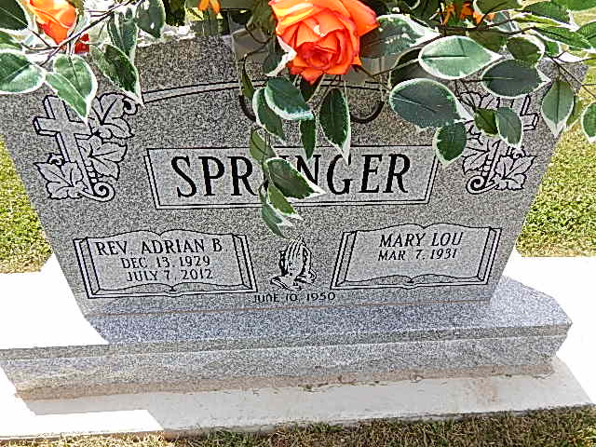
Photo by Alicia Kneuss

Adrian B. Sprunger, 82, died on July 7, 2012, at Good Shepherd Hospice in Auburndale, Florida. Adrian was born on December 13, 1929, in Berne, to the late Noah and Amelia (Badertscher) Sprunger. On June 10, 1950, he married the former Mary Lou Barger. Raised in Adams County, Adrian attended and graduated from Monroe High School. Upon graduation, he went to Bob Jones University, graduating in 1952 with a bachelor's degree in theology. He pastored churches in Pennsylvania, Indiana, Michigan and Missouri for over 50 years. Upon retiring he occasionally filled the pulpit for many pastors. His greatest desire was that the lost would come to know Jesus as their Savior. In 2006, he and his wife moved permanently to Florida.
He is survived by his wife of 62 years, Mary Lou Sprunger of Dundee, Fla.; his three children, Cheryl (John) Moore of Seymour, Ind.; Thomas (Becky) Sprunger of Rochester, Minn.; and Douglas (Teresa) Sprunger of Seymour; 15 grandchildren, 20 greatgrandchildren; three sisters, Helen Buckingham, Kathryn Sprunger and Marjorie Gaskill; a brother, Stanley Sprunger; and many nieces and nephews. He was preceded in death by a brother, Roger.
Visitation will be from 4-8 p.m. on Thursday, July 12, at Haggard-Sefton & Hirschy Funeral Home. Funeral Services will be at 10 a.m. on Friday, July 13, at Pleasant Dale Church of the Brethren. Pastor Jay Carter and Pastor Jeff Gaskill will be officiating. Burial will take place in Pleasant Dale Cemetery. Preferred memorials are to Good Shepherd Hospice-Auburndale, Fla.

Decatur Daily Democrat, Adams County, IN; July 11, 2012

