Larry G. “Butch” Settle
September 27, 1944 – August 20, 1987

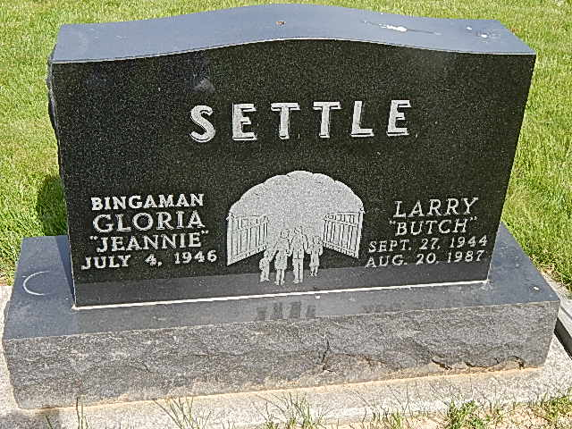

Photos by Alicia Kneuss

Crash Claims County Man
Larry J. Settle, 42, route 1, Monroe, driver for Smith Brothers Furniture Co., at Berne, was killed in the crash of his Smith Brothers tractor-trailer truck at 4:34 p.m. Thursday (Eastern Time) a few miles north of Harlan, Kentucky.
He was pronounced dead at the scene near the community of Rosspoint, Kentucky after the truck crossed US 119, went through a guardrail, and fell down a 60-foot embankment before stopping 100 feet from the Cumberland River, according to a representative of the Kentucky State Police. Mr. Settle was alone in the truck.
The vehicle was declared a total loss and its cargo of furniture was heavily damaged. Diesel fuel leaked from the truck, but there was no fire. The accident was investigated by the Kentucky State Police.
Larry Jean Settle was born in Wells County on September 27, 1944 to Lloyd and Dorothy Wilson-Settle and married the former Gloria Jean Robison on July 12, 1964 in Bluffton. His wife survives, as does his mother, a resident of Bluffton.
He was a Vietnam War veteran of the U.S. Marine Corps and was the first Wells County soldier to depart for Vietnam. He served a 13-month tour of duty.
He was a member of the Pleasant Dale Church of the Brethren and lived at route 1, Monroe for 20 years.
Other survivors include a daughter, Michelle Renee Settle, and a son, Thomas Dale Settle, both at home; two sisters, Mrs. Robert (Sue) Smith of Portland and Mrs. Milton (Shirley) Short of Bluffton; and two brothers, Robert Settle of Markle and Fred Settle of Pennville.
Funeral services will be held at 2 p.m. Sunday in Pleasant Dale Church of the Brethren, Rev. Norman Replogle officiating. Burial will be in the church cemetery. Pallbearers will be Jim Arnold, Jay Spann, Robert Neuenschwander, Chuck Huffman, Russell Waltmire, and Glen Yager. Honorary pallbearers will be Ron Hoffman, Wayne Byerly, Wayne Vardaman, Bob Mitchel, Lynn Dustman, and Bob Dressel.
There will be military graveside services following the funeral service.
Visitation is from 2-9 p.m. Saturday at Zwick-Boltz and Jahn Funeral Home and 1-2 p.m. Sunday at the church. Preferred memorials are gifts to the church's building fund.
Decatur Daily Democrat, Adams County, IN; August 21, 1987
*****
Larry Settle, 42, Dies in Truck Accident; Mother Bluffton Resident
Son of Mrs. Dorothy Settle of Bluffton, Larry J. Settle, 42, of Monroe Route 1, lost his life in a truck accident which occurred late Thursday afternoon in Harlan County, Kentucky.
According to reports, Mr. Settle was driving a semi-truck for Smith Brothers Furniture Co., of Berne and was near Lexington, Ky., making the last of his deliveries when the accident occurred. It is thought that he possibly suffered a heart attack at the time he lost control of the semi rig. He was pronounced dead at the scene.
The first Wells County man to serve in Vietnam, Mr. Settle was a member of the Marine Corps.
Born Sept. 27, 1944 in Wells County, he was a son of the late Lloyd Settle, and Dorothy Wilson Settle of Bluffton. His marriage to Gloria Jean Robison, who survives, took place in Bluffton July 12, 1964.
In addition to the wife and mother, surviving are a daughter, Michelle Renee Settle, a son, Thomas Dale Settle, both at home; two brothers, Robert Settle of Markle and Fred Settle of Pennville, and two sisters, Mrs. Robert (Sue) Smith of Portland and Mrs. Milton (Shirley) Short of Bluffton.
Friends will be received after 2 p.m. Saturday at the Zwick-Boltz and Jahn Funeral Home in Decatur. At 1 p.m. Sunday the body will be taken to the Pleasant Dale Church of the Brethren, of which Mr. Settle was a member, for services at 2 p.m. Rev. Norman Replogle will officiate at the rites and burial will be in the church cemetery with military graveside rites.
Preferred are memorials to the church building fund.
Bluffton News-Banner, Wells County, IN; August 21, 1987

