James Harold Roth
July 12, 1944 – July 13, 1944

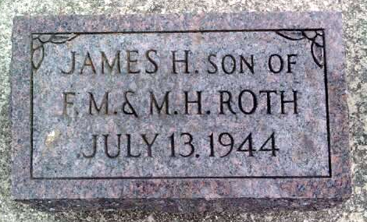
Photo by Deb Curry

James Harold Roth, day-old son of Mr. and Mrs. Floyd M. Roth, Kirkland Township, Adams County, died Friday at the Adams County Hospital at Decatur. The mother was formerly Mildred Henschen.
The parents and a brother, Roger, survive. Funeral services were held this morning with burial in the Pleasant Dale Cemetery.

Decatur Daily Democrat, Adams County, IN; July 13, 1944

