David Jennie Reidt
November 1, 1914 – July 17, 1987

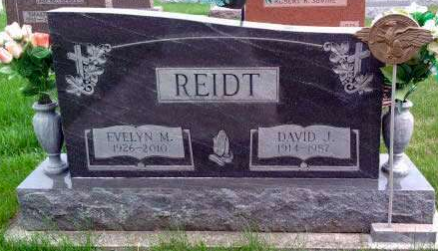
Photo by Deb Curry
Photo by Alicia Kneuss

David J. Reidt, 72, Craigville, a retired Fort Wayne General Electric Co. member, died at 11:40 p.m. Friday in Wells Community Hospital, Bluffton.
He was a member of Craigville United Methodist Church and a veteran of World War II. Born in Fort Wayne on Nov. 1, 1914, he was the son of Christian and Lula Deturk-Reidt, and was married May 17, 1945, to Evelyn Mankey; she survives.
Also surviving are three sons, Ronald E., Portland; Raymond D., Craigville; Norman L., Murray; six grandchildren; three sisters, Mrs. Clifford (Dorothy) Brown, route 2 Berne; Mrs. Rod (Marjorie) Forrester, Elkhart; Irene Reidt, Fort Wayne; three brothers, Arthur, Columbia City; Jack, Fort Wayne; and Donald, Fort Wayne.
Services will be held at 1:30 p.m. Monday at Thoma-Rich Funeral Home, Bluffton, Rev. Mike Overpeck and Rev. Stephanie Hill officiating. Burial will be in Pleasant Dale Cemetery. Friends may call at the funeral home today from 7-9 p.m. and Sunday after 2 p.m. Memorials are to the church.
Decatur Daily Democrat, Adams County, IN; July 18, 1987
*****
David J. Reidt, 72, of Rural Craigville, Dies; Rites Monday
Rural Craigville resident David J. Reidt, 72, died at 11:40 p.m. Friday at Wells Community Hospital, where he had been admitted two days earlier. He had suffered a stroke Dec. 14, 1986.
A veteran of World War II, he retired in 1977 after 32 years of service at General Electric Co. in Fort Wayne. He was a member of Craigville United Methodist Church.
Born Nov. 1, 1914 in Fort Wayne, he was a son of Christian B. and Lula May Deturk Reidt. His marriage to Evelyn May Mankey, who survives, took place in Wells County May 17, 1945.
Survivors include three sons, Raymond D. Reidt of Craigville, Norman L. Reidt of Murray and Ronald E Reidt of Portland; three sisters, Mrs. Clifford (Dorothy) Brown of Berne Route 2, Mrs. Rod (Marjorie) Forrester of Elkhart and Irene Reidt of Fort Wayne; three brothers, Jack Reidt and Donald Reidt, both of Fort Wayne and Arthur Reidt of Columbia City and six grandchildren.
The body is at Thoma-Rich Funeral Home, where friends may call from 7 to 9 p.m. today and from 2 to 9 p.m. Sunday. Rev. Mick Overpeck and Rev. Stephanie Hill will conduct services there at 1:30 p.m. Monday, and burial will be at Pleasant Dale Church Cemetery.
Preferred memorials are to the Craigville United Methodist Church.
Bluffton News-Banner, Wells County, IN; July 18, 1987

