Lewis E. Reber
December 31, 1873 – January 8, 1944

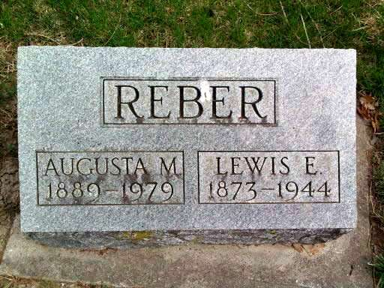
Photo by Deb Curry

LEWIS REBER RITES TO BE HELD TUESDAY
DEATH OCCURS SATURDAY EVENING FOLLOWING ILLNESS OF SEVERAL WEEKS
Lewis E. Reber, 74, died at 6:15 p.m. Saturday at his home on Hale Street, following an illness of three weeks from complications.
Mr. Reber was born Dec. 31, 1873 in Adams County, a son of Eli and Leah Hoffman Reber. His marriage Nov. 3, 1910, in Lima, O., was to Augusta Black, who survives.
Surviving besides the widow are three daughters, Mrs. Ruth Gehrett, near Bluffton, Mrs. Aretha Bushee, Ossian route 1, and Mrs. Flossie Hedges, of Fort Worth, Tex.; two sisters, Mrs. Iva Smith, of Bluffton, and Mrs. Carrie Glick, of Monroe, and a brother, Charles Reber, of Concrete, Wash. A son, a brother and a sister are deceased.
The body was taken to the Jahn Funeral Home, where it will remain for funeral services at 2 p.m. Tuesday in charge of Rev. Paul Mehrens, pastor of the Bluffton Church of Christ. Burial will be in the Pleasant Dale Cemetery in Kirkland Township, Adams County.
Bluffton News-Banner, Wells County, IN; January 10, 1944

