Marcellus C. Norris
August 17, 1853 – November 11, 1933

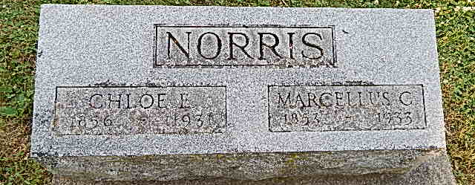
Photo by Alicia Kneuss
M. C. NORRIS DIES OF HEART ATTACK
DEATH OCCURS EARLY TODAY AND FUNERAL WILL BE
AT PLEASANT DALE
Marcellus C. Norris, 80, died at 7:40 this morning at his home on Lancaster Street following a heart attack, which he suffered Friday morning.
Born in Darke County, O., on Aug. 17, 1853, the deceased was a son of William and Mary Icenbarger Norris. His marriage to Miss Chloe E. Detrick took place in Georgetown, Darke County, O. She preceded him in death on April 3, 1931.
Surviving are eight children, Mrs. Emma I. Liby, Mrs. Nora M. Fulk, and William Norris, this city; Jessie C. Norris, Darke County, O.; Mrs. Verine Wolfe, Allen County; Adam W. Norris, Montgomery County, O.; Mrs. Esther Kinsey, Richland, Mich., and Mrs. Alice Smith, Adams county. Three daughters are deceased.
Brothers and sisters surviving are Austin Norris, Mrs. Ella Long, and Newton Norris, Darke county, O., and Mrs. Fora Minnich, Ohio.
Funeral services will be held at 1:30 Monday afternoon at the Pleasant Dale Church of which Mr. Norris was a member. Burial will be in the church cemetery.
Evening News-Banner, Wells County, IN; November 11, 1933

