Sylvanus C. Mills
June 11, 1850 – January 11, 1937

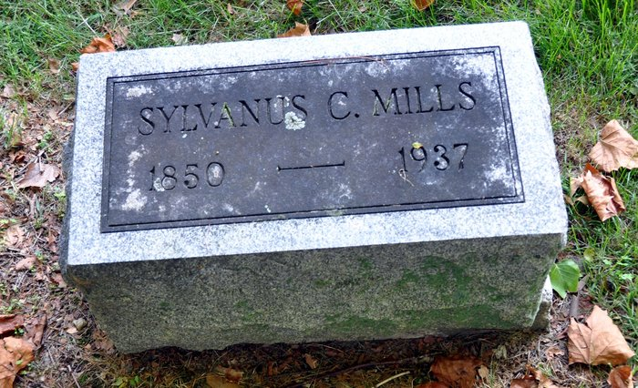
Photo by Deb Curry
Obit from Karin King

Former County Resident Dies
Sylvanus C. Mills Dies Monday at Grand Rapids, Michigan
Sylvanus C. Mills, 86, for many years a resident of Adams County, died at Grand Rapids, Michigan at 5 o'clock Monday morning, it was learned here today.
Paralysis was given as the cause of death. The deceased, who was the father of several local people, was born in Wells County on June 11, 1850, the son of Samuel and Magdalene Bender Mills.
He moved to Kirkland Township of this county, after his marriage to Elizabeth Stoneburner in 1875. The couple resided on a farm in that township until the death of his wife in 1890. In the year 1910 he moved to Grand Rapids, where he had resided since.
In 1892, he was married to Nancy Shell, also of Kirkland Township, who still survives. Three children were born to the first union. They are O. P. Mills, of Decatur; Mrs. John Beal, of Decatur route one and Ross Mills, of Detroit.
Three children also survive by the second marriage: Mrs. Frank Andrews, Detroit; Hubert, and Mrs. Orpha Chamberlain, both of Grand Rapids.
The deceased for a number of years taught school in Adams and Wells Counties, and was engaged in farming before leaving the state.
Funeral services will be held Wednesday afternoon a 3 o'clock at the Lobenstein funeral home in Monroe and burial will be made in the Pleasant Dale Cemetery in Kirkland Township.
Decatur Daily Democrat, Adams County, Indiana
January 12, 1937

