Lloyd E. Miller
November 4, 1919 – February 19, 2018

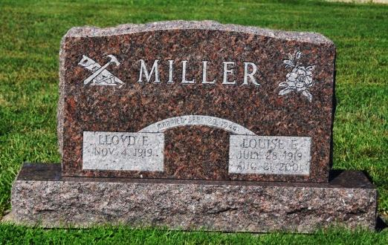
Photo by Deb Curry
Lloyd E. Miller, 98, of Decatur, Indiana passed away Monday, February 19, 2018 at Adams Heritage in Monroeville. He was born on November 4, 1919 in Decatur, Indiana to the late Emanuel James Miller & the late Sylvia Jeanetta (Brentlinger) Miller. He married Louise E. Renn on September 29, 1944 in Clarksburg, Maryland and she preceded him in death on August 21, 2001.
Lloyd was an honorably discharged veteran of the United States Army serving his country during WWII from 1942 to 1945 in the 3rd Chemical Battalion. He was a lifetime member of Pleasant Dale Church of the Brethren which his ancestors helped found & where he helped remodel the church. He was also a member of the Welcome Sunday School Class.
Lloyd retired after 40 years from Central Soya Company in Decatur where he served as an officer of the union. He also farmed for many years. After he retired he opened a woodworking shop as a hobby & enjoyed doing puzzles of all kinds. He enjoyed bowling until the age of 93.
Lloyd is survived by three daughters, Sylvia (James) Buettner of Ohio City, OH, Eva (Phillip) Maxwell of West Friendship, MD, & Donna (Richard) Breisch of Decatur; a son, Robert L. (Deborah) Miller of New Port Richey, FL; ten grandchildren; 19 great-grandchildren; & two great-great-grandchildren. He was preceded in death by six sisters, Nina Ross, Mildred M. Sills, Goldie M. Cook, Margaret M. Myers, Dorothy M. Springer & Nettie Jean Mabis; & and brother, Zeal J. Miller.
A funeral service will be held at 11:00 a.m. Saturday, February 24, 2018 at Pleasant Dale Church of the Brethren with Pastor Jay Carter officiating. Burial will follow at Pleasant Dale Church of the Brethren Cemetery with Military Graveside Services to be conducted by the American Legion Post #43 of Decatur.
Family and friends will be received from 3 to 7 p.m. Friday, February 23, 2018 at Zwick & Jahn Funeral Home in Decatur and one hour prior to the services Saturday at the church.
Preferred memorials are to Pleasant Dale Church of the Brethren Care & Share Fund.

Zwick & Jahn Funeral Home online obit (accessed February 20, 2018)

