Harvey R. Mankey
April 16, 1893 – December 4, 1968

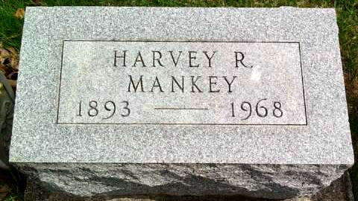
Photo by Deb Curry

Mankey funeral services Sunday
Funeral services will be held Sunday for Harvey R. Mankey, 75, retired farmer of Decatur route 2, who died at 10:45 p.m. Wednesday at Parkview Memorial Hospital, Fort Wayne, of a gunshot wound, self-inflicted at his home near Magley, early Wednesday night.
He was born in Adams County April 16, 1893, a son of Christ and Sarah Bridagam-Mankey, and was married to Emma Roth Nov. 26, 1919. His wife preceded him in death Nov. 30, 1939.
Mr. Mankey was a member of the St. Luke's United Church of Christ.
Surviving are one son, Dale E. Mankey of Decatur route 2; two daughters, Mrs. Bernard (Eleanor) Roehling of Woodburn, and Mrs. Lafie (Gladys) Leeth of Bluffton route 4; three brothers, J. W. Mankey of Decatur route 2, Forest Mankey of Craigville, and Ervin Mankey of Fort Wayne; 14 grandchildren. One sister and one brother are deceased.
Services will be held at 2 p.m. Sunday at St. Luke's United Church of Christ, with Rev. John Dulin officiating. Burial will be in the Pleasant Dale Cemetery. Friends may call at the Winteregg- Linn Funeral Home after 7 p.m. today until 11:30 a.m. Sunday, and at the church from 12 noon Sunday.
Decatur Daily Democrat, Adams County, IN; December 6, 1968

