Emma Virena (Brewster) Liby-Martz
August 17, 1897 – May 20, 1973

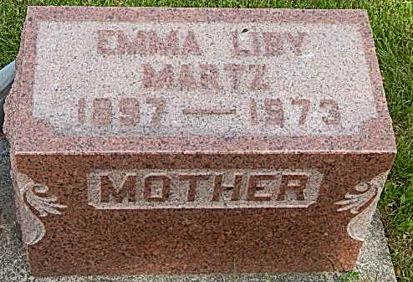
Photo by Alicia Kneuss

Emma V. Martz dies at hospital

Mrs. Emma V. Martz, 75, of 126 Walnut Street, Monroe, wife of Ferdinand Martz, died at 7 a.m. Sunday at the Fort Wayne Lutheran hospital. She had been a patient there for 12 days and in failing health for two months.
She was a member of the Pleasant Dale Church of the Brethren, Women's Fellowship and longtime member of the WCTU.
Born in Jefferson Township on Aug. 17, 1897, she was the daughter of Winfield and Jane Searight-Brewster, and was first married to Charles Liby who died on Sept. 17, 1954. She was later married to Ferdinand Martz in November of 1959.
Surviving are the husband; one daughter, Mrs. Lores (Martha) Steury of Milford; two sons, John W. Liby of Bluffton, and David C. Liby of route 4; five stepsons, Dale Liby of Decatur; Ralph Liby of Bluffton; Cledith L. Martz of Fort Wayne; Clyde Martz of Cincinnati, O.; and Clifton Martz of Fort Wayne; one step- daughter, Mrs. H. Wesley (Donna) Adams, Fort Wayne, one brother, Edward Brewster of route 1, Geneva; 29 grandchildren and eight great-grandchildren. Three brothers preceded her in death.
Funeral services will be held at 2:30 p.m. Tuesday at the Pleasant Dale Church of the Brethren, with Rev. J. Oliver Dearing officiating. Burial will be in the Pleasant Dale Cemetery. Friends may call at the Zwick Funeral Home after 2 p.m. today and until 1 p.m. and until 12 noon Tuesday, and at the church from 1 p.m. until time of the services. Preferred memorials are to the church building fund.
Decatur Daily Democrat, Adams County, IN; May 21, 1973

