Charles E. Liby
September 20, 1891 – September 17, 1954
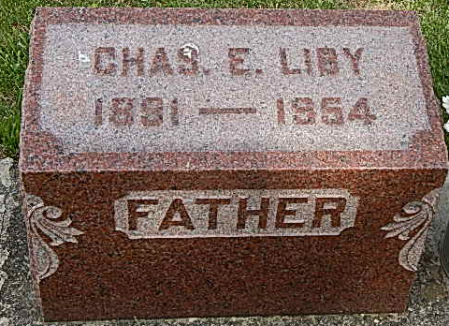
Photo by Alicia Kneuss

Charles Liby Dies Suddenly At Home
Funeral Services Monday Afternoon
Charles E. Liby, 62, well known Kirkland Township farmer, died suddenly at 7:45 o'clock this morning at his home three and one-half miles south of Magley. Death was caused by a heart attack.
He was born in Kirkland Township Sept. 20, 1891, a son of Wallace and Rosa Murphy-Liby, and was married to Emma Brewster June 12, 1922. He lived practically his entire life in Kirkland Township.
Mr. Liby was a member of the Pleasant Dale Church of the Brethren.
Surviving in addition to the wife are four sons, Dale E. Liby of Decatur, Ralph D. of Bluffton, John W. of New Haven, and David C. at home; one daughter, Mrs. Lores Steury of Berne; seven grandchildren; five brothers, Alex of Zenith, Kan., Raymond of Three Rivers, Mich., Gerald of Fort Wayne and William and Fred of Linn Grove, and three sisters, Mrs. Jennie Cline of Linn Grove, Mrs. Roy French of Rockford, O., and Mrs. Mae Shanks of Linn Grove. One brother is deceased.
Funeral services will be conducted at 1:30 p.m. Monday at the Zwick funeral home and at 2 p.m. at the Pleasant Dale Church of the Brethren, the Rev. John Mishler and the Rev. Russell Weller officiating. Burial will be in the church cemetery. Friends may call at the funeral home after 2 p.m. Saturday. Friends are asked to omit flowers but may contribute to their favorite charities.
Decatur Daily Democrat, Adams County, IN; September 17, 1954
*****
Charles E. Liby's Death is Sudden
Charles E. Liby, 62, died suddenly at 7:45 this morning at his home three and one-half miles south of Magley in Kirkland Township, Adams County. Death was attributed to a heart attack.
Born Sept. 20, 1891, in Kirkland Township, he was the son of Wallace and Rosa Murphy Liby. His marriage to Emma Brewster, who survives, took place June 12, 1922.
A farmer, Mr. Liby was a member of the Pleasant Dale Church of the Brethren and had spent most of his life in Kirkland Township.
Surviving in addition to the wife, are four sons, Dale E. Liby of Decatur, Ralph D. Liby of Bluffton, John W. Liby of New Haven and David C. Liby, at home; a daughter, Mrs. Lores Steury of Berne; five brothers, Alex Liby of Zenith, Kan., Raymond Liby of Three Rivers, Mich., Gerald Liby of Fort Wayne and William and Fred Liby of Linn Grove; three sisters, Mrs. Jennie Cline and Mrs. Mae Shanks of Linn Grove and Mrs. Roy French of Rockford, O., and seven grandchildren. A brother is deceased.
The body was taken to the Zwick Funeral Home at Decatur where friends may call after 2 p.m. Saturday.
Funeral services will be held at 1:30 Monday at the funeral home and at 2 p.m. at the Pleasant Dale Church of the Brethren. Rev. John Mishler and Rev. Russell Weller will officiate and burial will be in the church cemetery.
Friends are asked to omit flowers and give to their favorite charity.
Bluffton News-Banner, Wells County, IN; September 17, 1954

