Ralph V. Leyse
March 3, 1914 – February 5, 1995

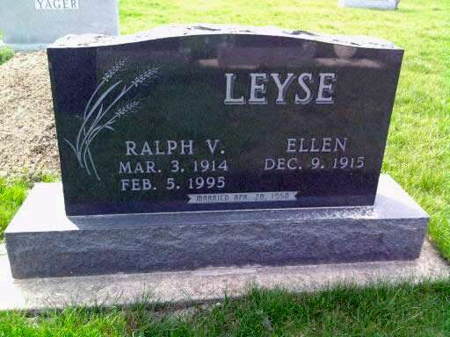
Photo by Deb Curry

Ralph V. Leyse, 80, rural Decatur, died at 11:50 p.m. Sunday in Adams County Memorial Hospital. He was born on March 3, 1914 in Adams County to Samuel J. and Katherine Oehler Leyse and married Ellen Beer on April 28, 1950. She survives.
He was a farmer and a retired butcher who worked at Gerber's Grocery and Heyerly Grocery. He was a member of Pleasant Dale Church of the Brethren.
Other survivors are two sons, Dean E. Leyse, Lafayette, Louisiana, and Dennis L. Leyse, Decatur; a daughter, Mrs. Jeff (Gretchen) Hatchett, Elgin, Illinois; and five grandchildren. Deceased are a brother, John Leyse, and five sisters, Ruth Gahman, Nora Arnold, Mabel Arnold, Elizabeth Mulligan, and Frances Leyse.
Funeral services will be at 11 a.m. Wednesday in Pleasant Dale Church of the Brethren, with burial in the church cemetery. Visiting hours are 2-9 p.m. Tuesday in Haggard and Armes Funeral Home, Decatur, and 10-11 a.m. Wednesday in the church. Preferred memorials are to the Pleasant Dale church's Care and Share Fund or Crossroads Children's Home in Fort Wayne.
Decatur Daily Democrat, Adams County, IN; February 6, 1995
*****
Ralph V. Leyse, 80
Ralph V. Leyse, 80, of rural Decatur, died at 11:50 p.m. Sunday at Adams County Memorial Hospital.
Born March 3, 1914 in Adams County, he was a son of Samuel J. and Katherine Oehler Leyse. His marriage April 28, 1950 was to Ellen Beer, who survives.
Mr. Leyse was a farmer and retired butcher, having worked at Gerber's Grocery and Heyerly Grocery. He was a member of the Pleasant Dale Church of the Brethren.
In addition to the wife, surviving are two sons, Dean F. Leyse of Lafayette, La., and Dennis L. Leyse of Decatur; a daughter, Mrs. Jeff (Gretchen) Hatchett of Elgin, Ill.; and five grandchildren.
Rites will be officiated by Rev. Norman Replogle at 11 a.m. Wednesday at Pleasant Dale Church of the Brethren. Friends may call from 2 to 9 p.m. Tuesday at Haggard & Armes Funeral Home, and one hour prior to rites at the church. Burial will be in the church cemetery.
Memorials to the Pleasant Dale Share and Care Fund or Crossroads Fort Wayne Children’s Home.
Bluffton News-Banner, Wells County, IN; February 6, 1995

