E. Pauline Lewis
1909 – December 24, 1992

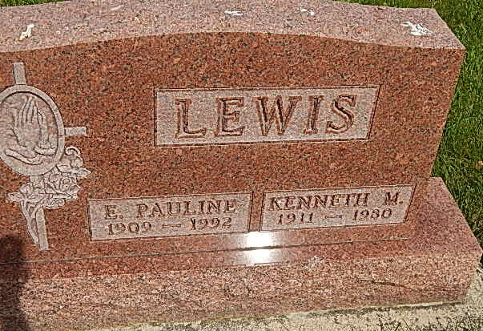
Photo by Alicia Kneuss

E. Pauline Lewis, 83, of Fort Wayne died Thursday in Byron Health Center. The Adams County native was a nurse's aide and widow of Kenneth, who died in 1980.
Surviving are daughters, Maureen Murtaugh of Fort Wayne, Sheila Samson of Dayton, Ohio, and Karen Junk of Laguna Beach, Calif.; son, Tim Murtaugh of Fort Wayne; two grandchildren; and three great-grandchildren.
Graveside services are 1 p.m. Wednesday in Pleasant Dale Cemetery, Adams County. There is no calling in Myers Funeral Home, Huntington. Preferred memorials are gifts to the Society for the Prevention of Cruelty to Animals in Fort Wayne.

Fort Wayne News-Sentinel (IN); December 28, 1992

Contributed by Jane Edson

