Willard E. Landis
October 5, 1927 – January 17, 2014

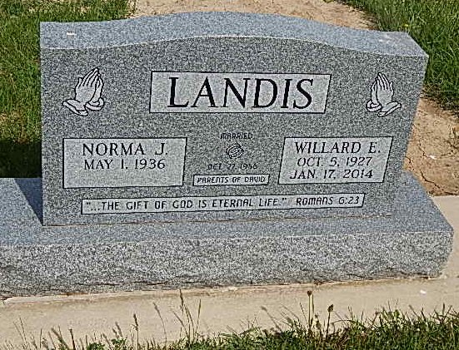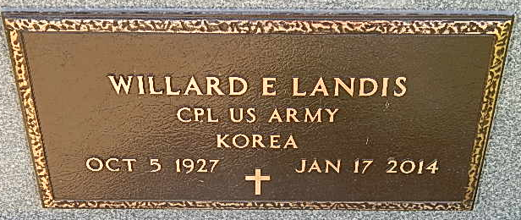
Photos by Alicia Kneuss

Willard E. Landis, 86 years old of Decatur, Indiana, passed away at 1:10 p.m. on Friday, January 17, 2014 at his residence. Willard was born on Wednesday, October 5, 1927 in Adams County, Indiana the son of the late Earl S. Landis and the late Bertha L. (Fugate) Landis. He married Norma J. Agler on October 27, 1956 in Decatur, Indiana and she survives.
Willard attended the Decatur Church of God and was a graduate of Kirkland High School in 1947. Willard served his country in the United States Army during the Korean Conflict. Willard retired in 1985 from International Harvester with 30 years of service.
Surviving are his wife, Norma J. Landis of Decatur, IN; son, David A. (Lori) Landis of Decatur, IN; brother, Arthur Landis of Decatur, IN; brother, Clifford (Dixie) Landis of Decatur, IN; brother, Cleo Landis of Columbia City, IN; grandson, Justin (Brittney) Landis of Decatur, IN; granddaughter, Caitlin (Travis) Kashner of Decatur, IN; and 3 great-grandchildren: Craig, Layla, and Arabelle Landis.
Preceding Willard in death were 2 sisters, Ruth Landis & Marie Mitchel; and 4 brothers, Herman Landis, Harvey Landis, Homer Landis, and Leonard Landis.
Funeral services will be held at 2:00 p.m. Monday, January 20, 2014 in the Decatur Church of God with Dr. Robert Brink officiating. Interment will follow in the Pleasant Dale Cemetery, rural Decatur, Indiana.
Friends will be received from 12:00 Noon -5:00 p.m. Sunday, January 19, 2014 in the Zwick & Jahn Funeral Home, Decatur, IN and one hour prior to the service at the church on Monday.
Zwick & Jahn Funeral Home online obit (accessed January 17, 2014)

