Mary E. (Miller) Householder
March 1, 1854 – February 4, 1908

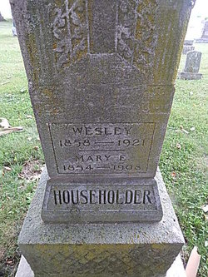
Photo by Alicia Kneuss

Death of Mrs. Householder from Pneumonia
Lancaster Township Lady Died This Morning--Funeral Wednesday
Mary, wife of Wesley Householder, died this morning at three o'clock at their home north east of this city. While she had suffered some from lung trouble she became sick with a severe attack of pneumonia last Thursday and her death soon followed.
Mrs. Householder was the daughter of Constantine and Sina Miller and was born in Fairfield County, Ohio. Her age was fifty-four years, eleven months and three days. She was united in marriage to Wesley Householder and leaves a husband and three children, Herbert, aged 21, Naomi, 19, and Martha, 16. Both her parents are dead.
Mrs. Householder has been a resident of this county for many years and leaves a large number of relatives and friends to mourn her departure. The funeral will be held at Pleasant Dale, Adams County; the funeral cortege leaving the house at twelve o'clock Wednesday.

The Evening News, Wells County, IN; February 4, 1908
*****
DEATH OF MRS HOUSEHOLDER FROM PNEUMONIA
LANCASTER TOWNSHIP LADY DIED THIS MORNING.--FUNERAL WEDNESDAY
Mary, wife of Wesley Householder, dies Tuesday at three o'clock A.M., at their home north east of this city. While she had suffered some from lung trouble she became sick with a severe attack of pneumonia last Thursday and her death soon followed.
Mrs. Householder was the daughter of Constantine and Sina Miller and was born in Fairfield County, Ohio. Her age was fifty four years eleven months and three days. She was united in marriage to Wesley Householder and leaves a husband and three children, Herbert, aged 21, Naomi, 19 and Martha 16. Both her parents are dead.
Mrs. Householder has been a resident of this county for many years and leaves a large number of relatives and friends to mourn her departure. The funeral was held at Pleasant Dale, Adams County, the funeral cortege leaving the house at twelve o'clock Wednesday.
Bluffton Chronicle, Wells County, IN; February 5, 1908

