Ronald Lee Hoffman
August 5, 1941 – June 24, 1994

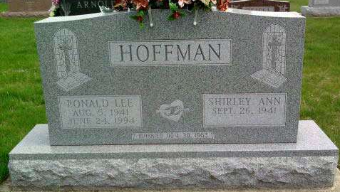
Photo by Deb Curry

Ronald L. Hoffman, 52, of 963 Yorktown Rd., died at 3:30 a.m. today in his home. He was born Aug. 5, 1941, in Adams County, the son of Harold and Myrtle (Schrock) Hoffman. On Nov. 39, 1963 he married Shirley Liby, who survives.
Other survivors include two daughters, Mrs. Jeff (Michele) Warner and Mrs. Mike (Stephanie) Fawcett, both of Decatur; his father and stepmother, Harold and Mary Hoffman of Preble; a brother, Michael D., Decatur; two stepbrothers, Thomas W. Sheets, Decatur and Jessie Sheets of Texas; a sister, Mrs. Richard (Ruth Ann) Penrod of Decatur; two stepsisters, Mrs. Allan (Vicki) Milholland and Julie O'Beirne, both of Decatur; and three grandchildren.
Mr. Hoffman had retired in 1991 after 31 years from International Harvester Navistar Division. He was a member of the Pleasant Dale Church of the Brethren, a former church trustee and building fund treasurer.
Funeral services will be held at 11 a.m. Monday in the Pleasant Dale Church of the Brethren. Burial will be in the church cemetery. Calling hours are from 7-9 p.m. Saturday and from 11 a.m. to 1 p.m., 2-5 and 7-9 p.m. Sunday in Haggard & Armes Funeral Home, Decatur, and one hour prior to services in the church Monday. Preferred memorials are to the church building fund.
Decatur Daily Democrat, Adams County, IN; June 24, 1994
*****
Memorials for Ronald L. Hoffman, 52, 936 Yorktown Road, may also be made to the American Cancer Society. Mr. Hoffman died at 3:30 a.m. Friday in his home. A complete obituary appeared in Friday's edition of the Decatur Daily Democrat.
Decatur Daily Democrat, Adams County, IN; June 25, 1994

