Paul R. Hamrick
March 10, 1929 – April 29, 2011

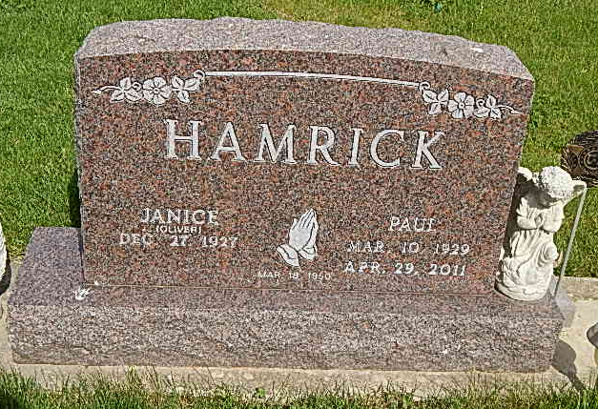
Photo by Alicia Kneuss

Paul R. Hamrick, 82, of Fort Wayne, formerly of Monroe, passed away at 2:30 p.m. on Friday, April 29, 2011, at Coventry Meadows in Fort Wayne. He married Janice A. Oliver on March 18, 1950.
He is survived by his wife of 61 years, Janice Hamrick of Fort Wayne; a son, Dr. Bradley P. (Leah) Hamrick of Avon, Indiana; a daughter, Brenda K. Hamrick, of New Haven; three brothers, Charles (Ethel) Hamrick of Decatur; Clarence (Kate) Hamrick of Willshire, Ohio; and Duane (Jeanie) Hamrick of Rockford, Ohio; two sisters, Norma (Lindy) Lybarger of North Manchester, and Carylon (Tom) Baker of Celina, Ohio; three grandchildren, Bryce, Christopher, and Elizabeth Hamrick of Avon; and special friends Sonny and Kackie Baugher of Elkton, Virginia. He was preceded in death by a brother, Vic Hamrick, and a sister, Evelyn Luginbill.
He was a member of Pleasant Dale Church of the Brethren in rural Decatur. Paul served in the U. S. Army from 1952-1954 during the Korean Conflict. He retired in 1982 from International Harvester after almost 31 years of service.
Visitation is 4 to 8 p.m. today, May 2, 2011, at Haggard-Sefton and Hirschy Funeral Home, Decatur, and one hour prior to the service at the church on Tuesday.Funeral services will be held at 10:30 a.m. on Tuesday, May 3, 2011, at Pleasant Dale Church of the Brethren, with Pastor Jay Carter officiating. Burial will take place in Pleasant Dale Cemetery, with military graveside rites conducted by the American Legion Post 43 color guard.
Memorials may be made to Pleasant Dale Church of the Brethren or to the Alzheimer's Association of Fort Wayne.

Decatur Daily Democrat, Adams County, IN; May 2, 2011

