Ruth Hamilton
June 6, 1923 – June 6, 1923

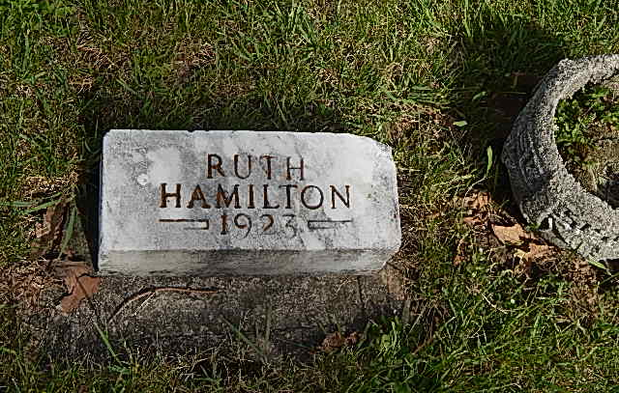
Photo by Alicia Kneuss

INFANT HAMILTON CHILD DIED SOON AFTER BIRTH

Ruth Hamilton, infant daughter of Mr. and Mrs. Ray Hamilton, died at her home near the Pleasant Dale church northwest of Decatur at 5:30 o'clock yesterday evening, shortly after birth. The child lived approximately one hour. Besides her parents, she is survived by one brother, Lewis, and one sister, Mary Jane. The funeral services were held from the home at 2:30 o'clock this afternoon, the Rev. U. S. A. Bridge, pastor of the First Methodist church of this city, officiating. Burial was made in the Pleasant Dale cemetery.

Decatur Daily Democrat, Adams County, Indiana; Thursday, June 7, 1923

Contributed by Karin King

