Mabel Viola Glick
March 16, 1898 – January 22, 1907

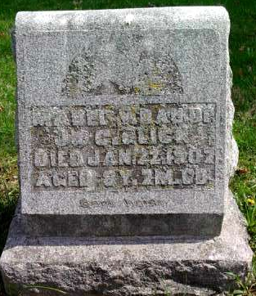
Photo by Alicia Kneuss

Mabel Viola Glick, the only daughter of Mr. and Mrs. James Glick departed this life January 22, 1907. She was taken ill two weeks ago with a severe cold. Bronchial- pneumonia developed and her death resulted. She was born March 16, 1898, age eight years, seven months, and six days.
Though but a little girl her last words should be remembered by everyone. She said, "I want to go where Jesus is," and just a short time before her death she told her mamma, "I am getting ready to go."
Mabel has joined that innumerable throng, who have preceded her to that land of eternal bliss and happiness where there is no heartache, trouble, pain, or death, and where sorrow or sadness never come. She will be greatly missed by her parents, classmates and friends, as she was liked by all who knew her.
There is left to mourn her death a father, mother, two grandmothers, one grandfather and a large circle of friends.
The funeral service was held at the C.U. church at Craigville, Thursday January 24, at 10 o'clock conducted by Rev. Pain. Interment at Pleasant Dale Cemetery.
Bluffton Chronicle, Wells County, IN; January 30, 1907

