Frances Lucille (Henschen) Freels
February 17, 1910 – January 11, 2002

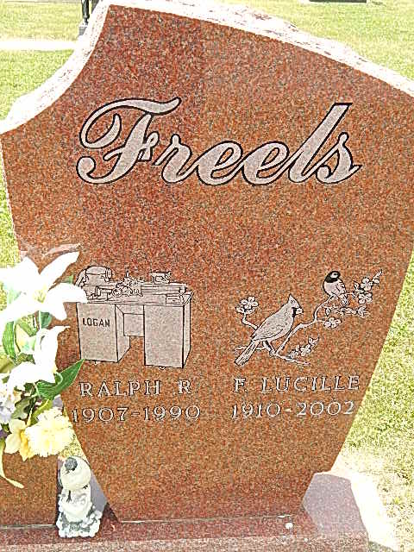
Photo by Alicia Kneuss

Frances Lucille Freels, 91, Berne, a former Kirkland Township resident, died in Swiss Village at 5:35 p.m. Friday. She was born February 17, 1910 in Adams County to Samuel D. and Florence Yaney Henschen and married Ralph D. Freels on June 4, 1932; he died on July 21, 1990.
She was a homemaker who also retired from the Adams Central School cafeteria. She was a member of Pleasant Dale Church of the Brethren and its Women's Fellowship group and was a long- time Sunday School teacher.
Mrs. Freels was a charter member of the Kirkland Ladies' Club and the Sunbeam Garden Club. She was also a leader of Seedlings Junior Garden Club and a volunteer at the former Lakeside Manor Nursing Home and Swiss Village's Nursing Care Craft Department.
Surviving are a son, Allen Freels of Albion; two daughters, Mrs. Gene (Elaine) Bluhm of rural Monroe and Mrs. Ronald (Arlene) Corson of Syracuse; a sister, Mildred Roth of Berne; a sister-in-law, Alice Henschen of Decatur; eight grandchildren; 18 great-grandchildren; and four great-great-grandchildren.
A sister, a brother, and a stepbrother are deceased.
Funeral services will be at 11 a.m. Monday in Pleasant Dale Church of the Brethren, with burial in the church cemetery.
Visiting hours are noon - 6 p.m. Sunday in Haggard and Sefton Funeral Home and 10 - 11 a.m. Monday in the church.
Preferred memorials are to the church, Swiss Village's Activities and Crafts in Health Care, or the Hospice of Northeast Indiana at Berne.
The Decatur Daily Democrat, Adams County, IN; January 12, 2002

