Vernal Ellenberger
August 14, 1909 – November 26, 1999

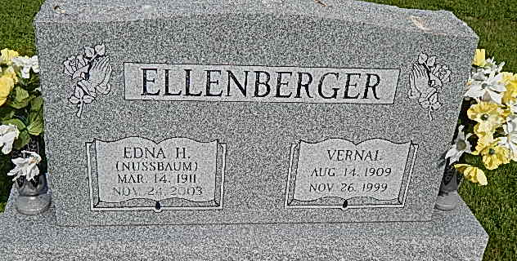
Photo by Alicia Kneuss

Vernal Ellenberger
Vernal Ellenberger, 90, Fort Wayne, died at 12:30 p.m. Friday at University Park Nursing Home in Fort Wayne. He was born in Berne on August 14, 1909 to Noah and Leah Luginbill Ellenberger. He was married to Edna Nussbaum on December 23, 1928; she survives.
Other survivors include a son, Duane Ellenberger, Fort Wayne; two sisters, Willodean Halberstadt and Vera Jane Hay, both of Decatur; two grandchildren and three great-grandchildren.
He was preceded in death by four brothers -- Joyce, Eldon, Roy, Noah Jr. -- and four sisters, Goldie, Flossie, Virena, and Katie.
Mr. Ellenberger was a member of Bethel Brethren church. He retired from Dunbar Furniture in Berne in 1974.
Funeral services are at 10 a.m. Tuesday at Haggard & Sefton Funeral Home with burial at Pleasant Dale Cemetery. Visiting hours are 2-4 p.m. and 6-8 p.m. Monday. Memorials are to the American Heart Association.
The Decatur Daily Democrat, Adams County, IN; November 27, 1999
Contributed by Jane Edson

