Hugh L. Ehrman
April 29, 1926 – June 20, 2012

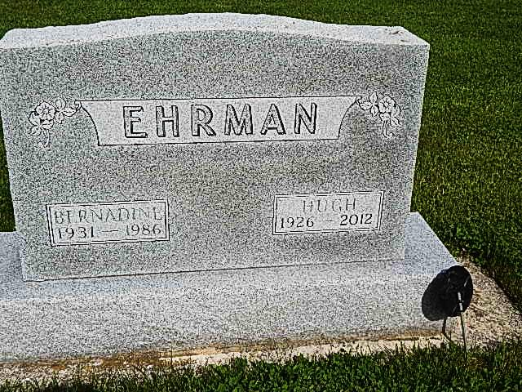
Photo by Alicia Kneuss

Hugh L. Ehrman, 86 of rural Decatur died Wednesday, June 20, 2012 at Adams Memorial Hospital. Hugh was born on April 29, 1926 in Preble, IN to the late Floyd W. and Lola E. (Barger) Ehrman. Hugh married his first wife Bernadine Kirchofer on Feb. 14, 1952, she passed away Aug. 24, 1986; he married his second wife Carol (Yoder) Nussbaum, she passed away Dec. 2, 2002; he married Alice (Yoder) Hirschy on Dec. 1, 2005.
Hugh was a member of Pleasant Dale Church of the Brethren, the Progressive Sunday School class, was on the ministerial board, a Trustee, was Treasurer of Pleasant Dale Cemetery Board, and was a custodian at the church. Hugh retired in 1988 from Automatic Sprinkler in Monroe after 26 years of service. He also served his country in the Korean War from 1948-1952.
Survivors include his wife Alice Hirschy Ehrman of Decatur; two sons Keith (Joanne) Ehrman of Bluffton and Kevin (Kim) Ehrman of Westminster, CO; three daugthers Mrs. Garry (Kay) Pearson of Davis, CA, Mrs. Mark (Kendra) Everett and Mrs. Michael (Kristi) Miller both of Decatur; five step sons Arnold Hirschy, Roger Hirschy, Stacy Hirschy, Gary Nussbaum and Todd Nussbaum; three step daughters Rosemary Love, Lisa Martin and Lana Gerber; a sister Ilene Reinhard of Craigville; 10 grandchildren, 9 great grandchildren and several step grandchildren.
Visitation will be from 2-4 & 6-8 p.m. Friday, June 22, 2012 at Haggard-Sefton & Hirschy Funeral Home and 1 hour prior to service at the church. Funeral service will be at 11:00 a.m. Saturday, June 23rd at Pleasant Dale Church of the Brethren. Pastor Jay Carter will be officiating and burial will be in Pleasant Dale Cemetery with Military Graveside Rite by American Legion Post 43 Color Guard.
Memorials are to Pleasant Dale Church of the Brethren.

Haggard & Sefton Funeral Home online obit (accessed June 20, 2012)

