George W. Drum
October 4, 1862 – June 3, 1917

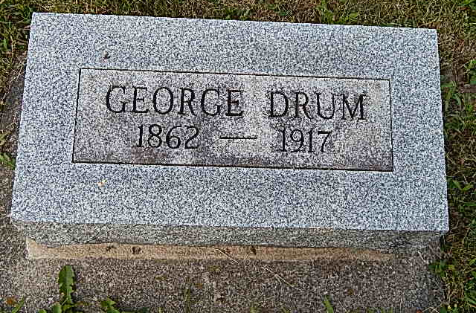
Photo by Alicia Kneuss

A Sudden Call
Comes for G. W. Drum, Prominent Curryville Merchant -- Fell Dead
Sunday Afternoon at Bluffton -- Was a Brother to Mrs. James Ward of This City
George W. Drum, aged fifty-four, half owner of Drum Brothers' General Store at Curryville, brother of Mrs. James Ward, and uncle of Mrs. Hugh Thomas Vail, this city fell dead from heart trouble at Bluffton yesterday afternoon while umpiring a baseball game between Curryville and the Bay Piano Factory team. He had run from second base to third while umpiring the bases and collapsed while slowly walking across the diamond. Drum had not been a sufferer from heart trouble previously, as far as is known.
Early in the game some of his decisions occasioned a great deal of protest and he told a bystander that he had difficulty in seeing the plays, expressing doubt as to whether or not he could finish the game. The game was in the fourth inning and the score was 2 to 2 when the fatal interruption occurred. He gave only a few gasps after members of the teams reached his side, but they continued to work with him until a physician arrived and pronounced life extinct.
Mr. Drum was born and raised in Wells County and for several years has operated a general store in partnership with his two brothers. He was a bachelor and the only surviving relatives are the following brothers and sisters: Joseph B. Drum, Peter H. Drum, Mrs. William Stalter and Mrs. Margaret Howard, of Curryville, and Mrs. James Ward, of Decatur. His two brothers, Joseph and Peter Drum, were in the crowd at the game.
The body was removed by Coroner Thoma.
The funeral will be Tuesday afternoon at the Dunkard Church.
Mr. Drum was also an uncle of Allen Stalter, an assistant in the county auditor's office; and of Nathan Stalter, son-in-law of County Auditor John Mosure.
Decatur Daily Democrat, Adams County, IN; June 4, 1917

