Elias Crist
June 22, 1836 – July 8, 1916

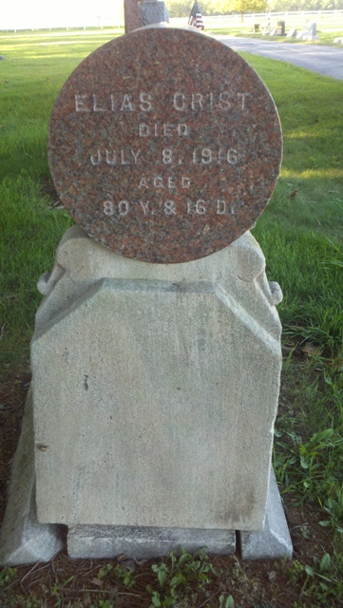
Photo by T & R Melton

ELI CRIST DEAD
Death Relieves Elias Crist of Sufferings at 12:25 This Morning.
ILL OVER TWO YEARS
Was Former County Assessor--Unconscious since Sunday
The death of Elias Crist, former county assessor, and widely known farmer, but of late years retired, occurred at 12:25 o'clock this morning following an illness from Bright's disease of nearly twenty-eight months. For the past week his condition had been critical and his death was expected almost hourly.
Mr. Crist was born in Mahoning County, Ohio, June 22, 1836, and was the son of Samuel and Sarah Crist, natives of Pennsylvania.
In the fall of 1845 he came to this county with his parents, who were located for a short time in Kirkland Township, then removing to Washington Township where his home has remained since. Following the death of his father the support of the family devolved upon the deceased. On October 27, 1859, he married Elizabeth Dunaphin, born June 25, 1840, in Fairfield County, Ohio. Her death occurred March 24, 1899. To this union were born six children, three of whom survive. In August, 1902, he married Estella Hunter Knodle of Bluffton, which she survives.
Early in life Mr. Crist was chosen assessor of Washington Township, and still later as county assessor, a position which he held for fourteen years. In 1909 he retired from active life. For forty-seven years he was a member of the Saint Mary's Lodge, No. 167, Independent Order of Odd Fellows of this city, and was also one of the first members of the Reiter Encampment. Early in the history of the local lodge he was advanced by his brethren to the highest honor they may bestow--noble grand--and on occasions he walked from his farm, five miles southwest of the city, to be in attendance at the meetings of the lodge.
His illness has been lengthy, he being first taken seriously twenty- eight months ago, when an early attack nearly proved fatal. Since last Sunday he has laid in an unconscious condition, being unable to even recognize his closest relatives.
He is survived by the wife, Mrs. Estella Crist; one brother, George, of Kirkland Township; one sister, Mrs. Elizabeth Schafer, of Elkhart; and three children, Mrs. B. F. Breiner, of Washington Township; Mrs. J. M. Andrews of Monroe, and John F. Crist of Monroe.
Thirteen grandchildren and four great-grandchildren also survive. Three sons have preceded Mr. Crist in death.
Funeral services will be held from the home, 515 Line Street, Monday morning at ten o'clock, Rev. D. T. Stephenson of Muncie officiating. The Odd Fellows will have fraternal charge. Burial will be in the Steele Cemetery.
Decatur Daily Democrat, Adams County, IN; July 8, 1916

*****
Funeral Held This Morning
Rev. D. T. Stephenson, of Muncie former pastor of the Decatur Methodist Church, conducted the funeral services this morning for the late Elias Crist, at the family home on Line Street. He paid a fine tribute to the deceased, and to pioneers in general, who laid the foundation for the success and prosperity enjoyed by the present generation. The I.O.O.F. conducted its ritualistic service also and pall bearers were chosen from its body. Burial took place in the Steele Cemetery.
Decatur Daily Democrat; July 10, 1916

