Fern E. (Syler) Byerly
1896 – June 7, 1949

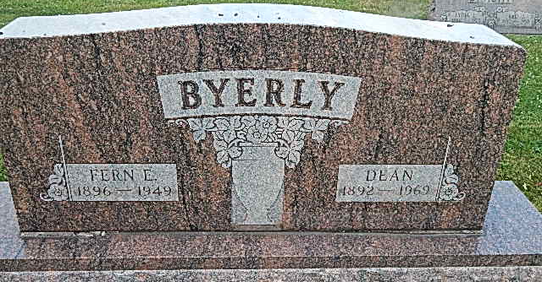
Photo by Alicia Kneuss

FALL INJURIES FATAL
Fort Wayne, Ind. June 8 –

Mrs. Fern Byerly, 53, Decatur, who was injured Friday in a fall into a grease pit at a local garage, died in a hospital yesterday. She is survived by the husband, Dean Byerly, one son and one daughter.

Kokomo Tribune (IN); June 8, 1949

